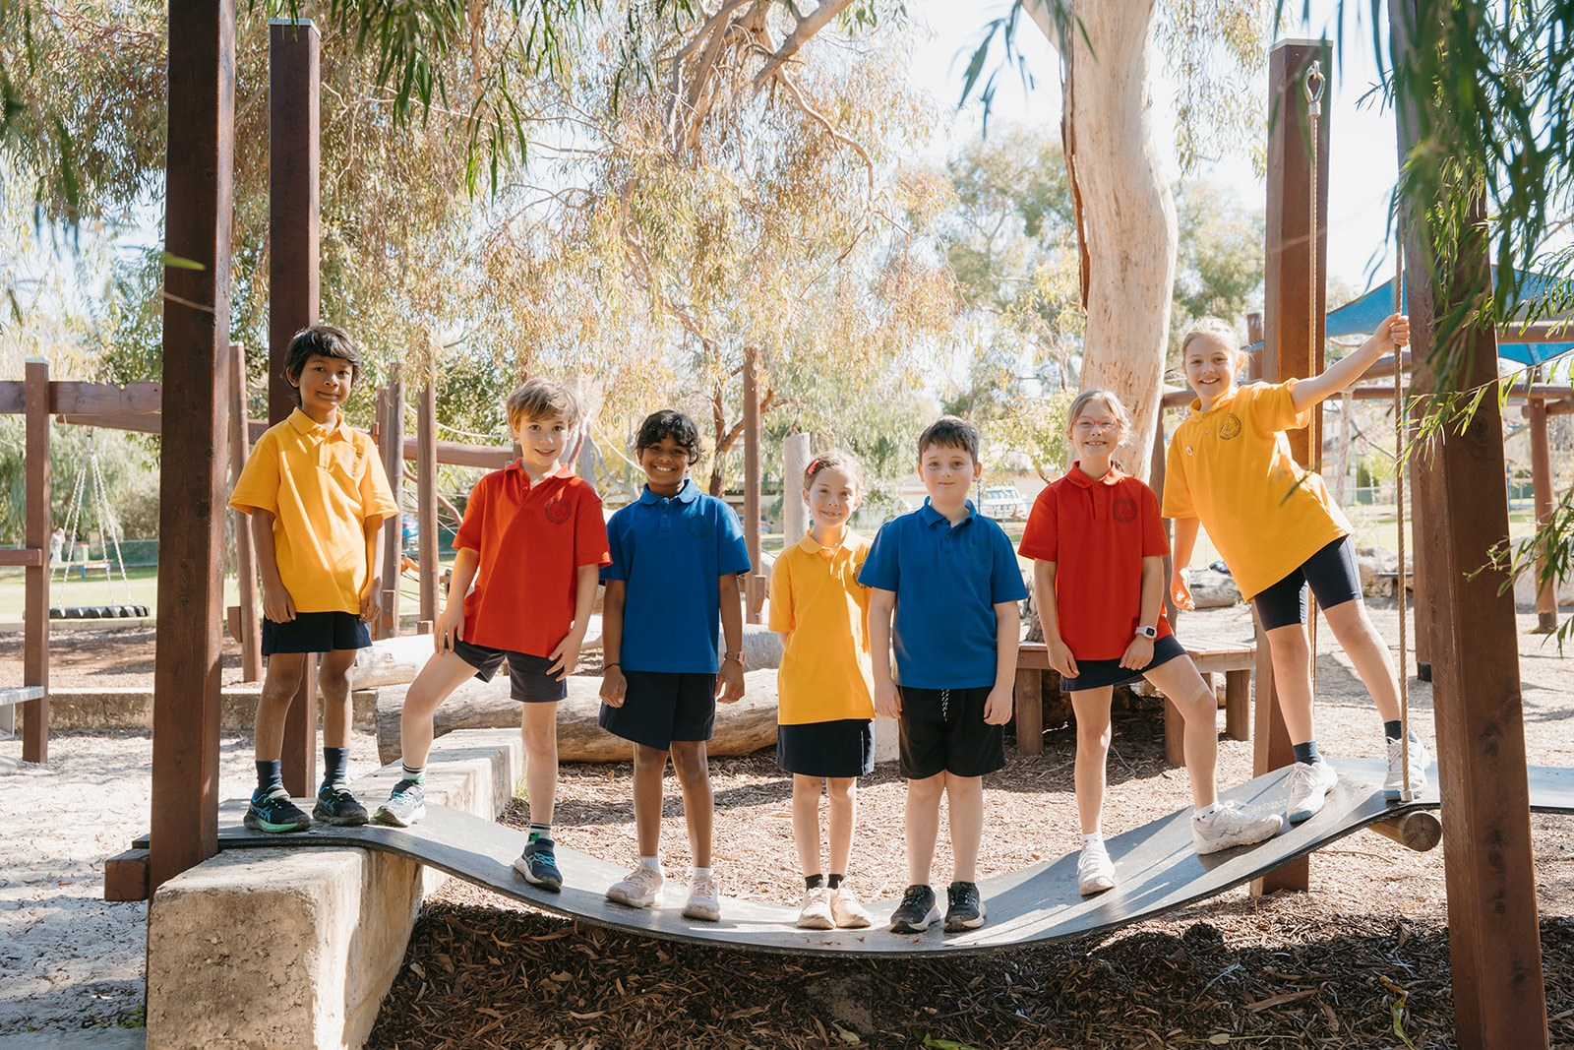

Mount Claremont Primary School, Term 2, Week 9
Ngany kaadijt, Wadjuk Noongar moort, keyen kaadak nidja boodjar. Ngany ni wer kaartidjin.
At Mount Claremont Primary School we acknowledge the traditional custodians of the land where we live, learn and work and the Wadjuk Noongar people. We acknowledge Wadjuk Noongar and Aboriginal and Torres Strait Islander Elders, their people and their land and waters.
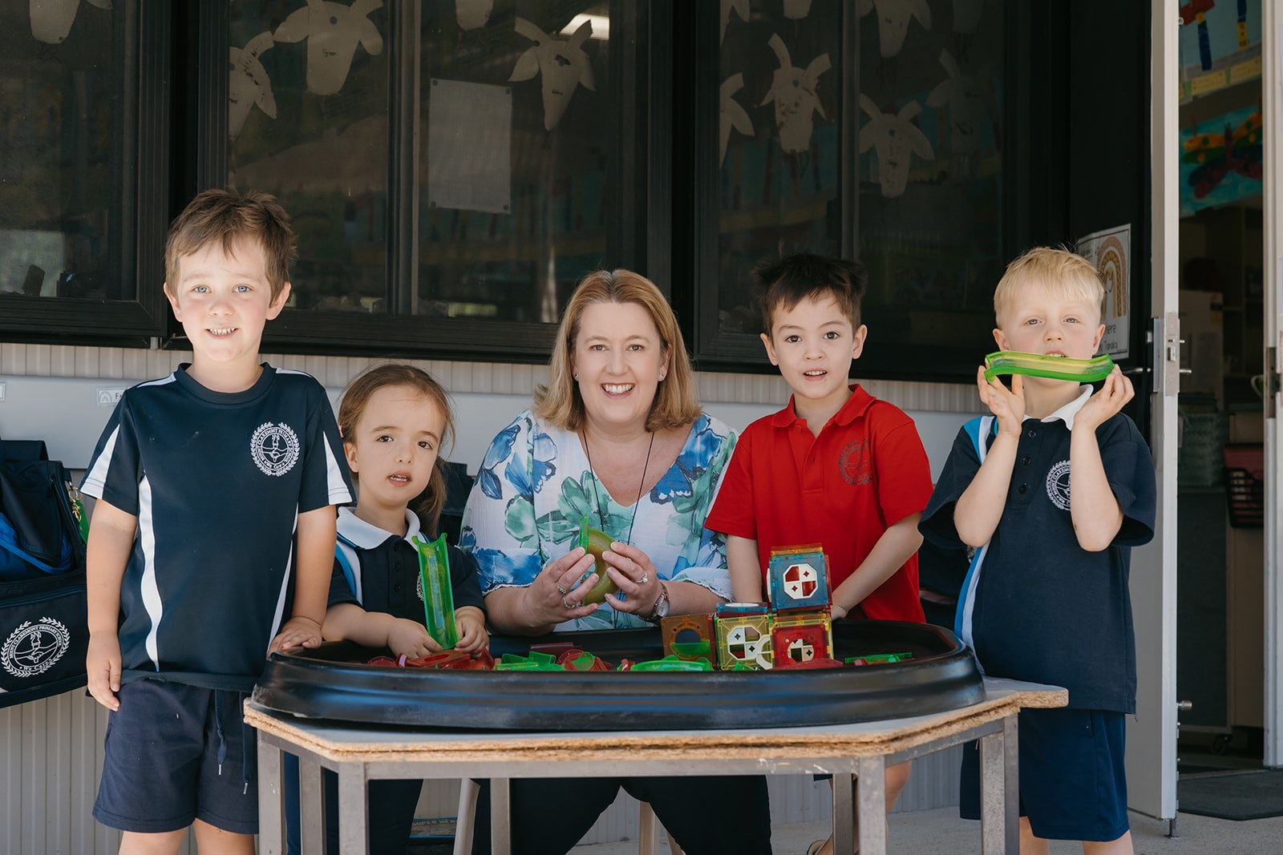
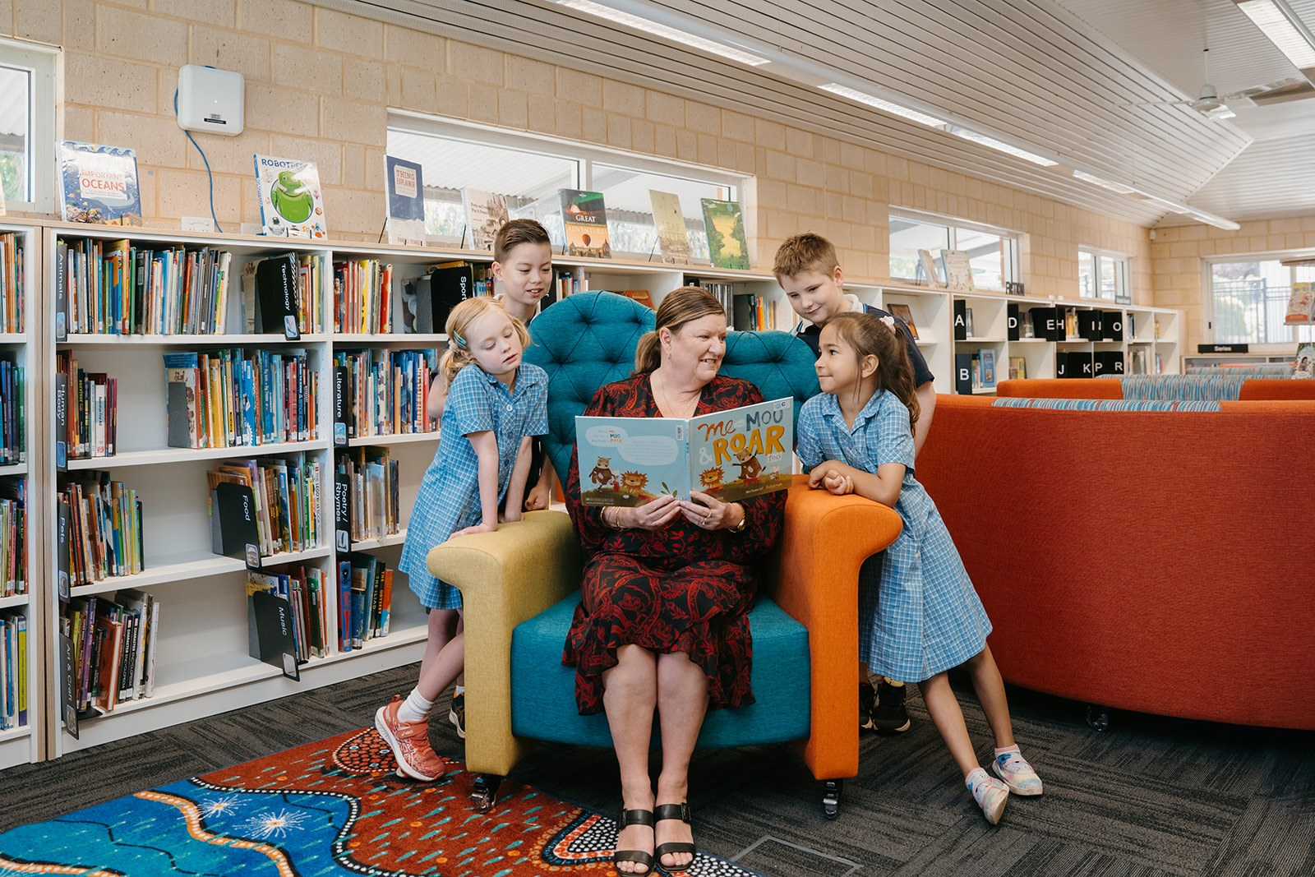

Important Dates
Term 2, 2026
23 June - Edu Dance Concert
25 June - Edu Dance Concert
26 June- Interschool Cross Country
29 June - Band Performance - OPUS
30 June- Lightning Carnival
30 June- Kindy Parent interviews 8.45-11.30am
1 July - Parent Interviews- Kindy to Year 6, 12pm finish for students
2 July - Pyjama Day Fundraiser and Bake Sale
3 July - Assembly Rm 17
- Last day of Term 2
Term 3, 2026
20 July - Staff Development Day - no school for students
21 July - Students commence school Term 3

From the Principal's Desk
Dear parents,
When you read this week’s newsletter, I hope your “heart sings”. There are some lovely educational experiences and enrichment opportunities provided at our school. Enjoy the photos too. We wish Mr Gardiner and the Years 6 Big Band Strawberry Jam all the best for their performance at the OPUS Concert, at Perth Modern School. We are very proud of you! We are all looking forward to the Dance concerts.

School Board
I am pleased to announce Jasmin Diab has appointed to the school board as a parent representative. Jasmin is mother of Zoe in Year 1, child with a disability. She is passionate about making sure school is place that is accessible for all students. Jasmin is a military veteran (nuclear engineer) and runs her own consultancy business. Jasmin is a graduate of the Australian Institute of Company Directors and a Fellow of Engineers Australia.
We farewell Libby Goodwin after serving 3 years on the Board. Libby has been proactive in the MCPS School Review process, policies and governance and provided an educational perspective. Libby has been a long serving member of the community in roles of Board, P&C, parent rep and market committee. Thank you, Libby, for giving your time, and expertise to the Board.
A parent vacancy will be advertised later in the year to commence 2027.

Staffing Changes
Miss Steph McCoach will be on parental leave at the end of term 2. Teachers appointed to Year 2, Room 12 are Mrs Megan Cicanese and Mrs Stehanie Kelly (formerly Heritage) returning from parental leave.
Ms Sarah Bishop has been appointed school officer.
I am so pleased to announce that Glenn Hall, Coordinator of TheirCare is back at Mt Claremont. He left suddenly to support another school, and now he is back here, where he belongs, with us! Glenn runs an outstanding OSH program. If you need before and after school care, go to the undercover area and have a talk to Glenn

Traffic Issues
Parking on Jacaranda and Lobelia St. The neighbours are getting a bit cranky because cars are double parked and blocking driveways in local streets. Please obey traffic signs and be considerate of others. The Ranger from City of Nedlands will be monitoring the parking and traffic. Save some money and do the right thing.
Parents using Alfred Road “drop off and pick up “zone have been courteous careful drivers. Keep up the good work!

Student Reports will be sent electronically to parents on Monday 29 June.
Parent teacher interviews are booked online: (see newsletter for details).
- Kindergarten Tuesday 30 June 8:45 to 11:30am and Wednesday 1 July 12:10 to 6:00pm
- Pre-primary to Year 6 Wednesday 1 July 12:10 to 6:00pm
School is closed on Wednesday 1 July from 12:00 noon for parent teacher interviews. TheirCare is open for bookings and Glenn the coordinator, runs an excellent program.

Western Power Substation
Work will be completed in the school holidays on the Western Power Substation, near the gate on Jacaranda Ave. The power upgrade is need for the school and neighbourhood. Power outages will occur on Friday 17 July. No impact to the Farmers Markets on Saturday.

Term 3
Monday 20 July is a school development day and students do not attend. Please make care arrangements for your children.

Tracey Oakes
Principal

Pyjama Day Fundraiser – Thursday 2 July
On Thursday 2 July, our Year 6 students will be hosting a Pyjama Day and bake sale to raise funds for Uplyft (formerly Wanslea) and Fostering Hope Australia, two organisations that support foster children and carers across Western Australia.

Students and staff are invited to wear pyjamas to school and take part in this fun community event!

At recess, Year 6 students will be selling a variety of food items outside the library. Please bring along a gold coin donation to the class teacher and a bag/purse with change to purchase a treat and support this worthwhile cause.

All funds raised will be shared equally between Uplyft and Fostering Hope Australia. Thank you for helping us make a positive difference in the lives of foster children and families in WA.

Kind regards,
Term 2 Fundraising Team
Mrs Marsh (Chaplain)
Miss Dalton (DSM Mentor)
Grace and Indiana (Care Captains)


Year 6 - Shenton College Visit
A huge thank you to Caitlyn and Bodhi, who returned to MCPS to speak with our current Year 6 students about their transition to high school, and specifically their experiences at Shenton College.
With Shenton College enrolments closing on Friday 24 July, this was a timely opportunity for students to ask questions and gain valuable insights from former MCPS students who have recently made the move to secondary school. Enrolment forms are at our front office or online.
Our Year 6s had plenty of questions and thoroughly enjoyed picking Caitlyn's and Bodhi's brains about subjects, teachers, friendships, routines and life at high school. It was wonderful to hear such positive reflections and experiences, and their honest and thoughtful answers helped reassure and inform many students as they prepare for this exciting next step.
Thank you, Caitlyn and Bodhi, for giving up your time to support our students. We greatly appreciate your willingness to share your experiences and represent both MCPS and Shenton College so positively.
Alexandra Malloch
Year 6 Class Teacher
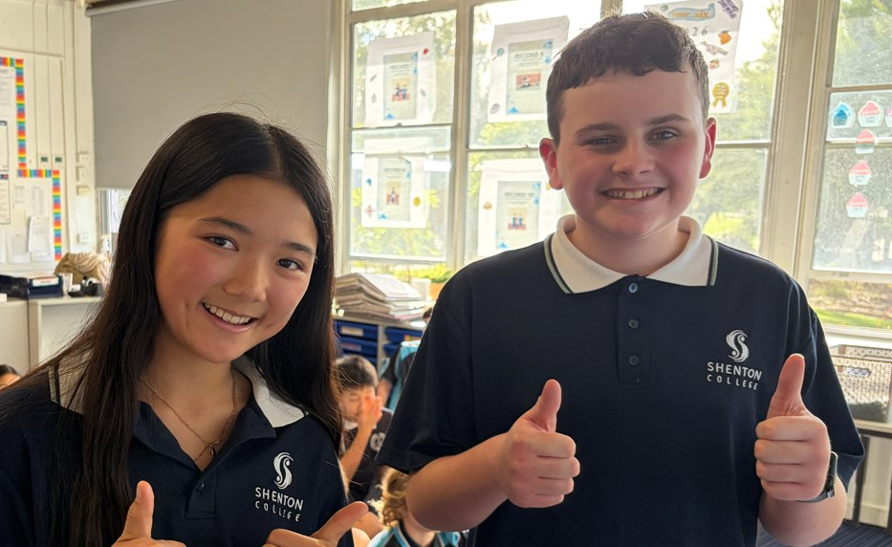

Camp Boshack - Year 6
Year 6 Camp 2026, A Resounding Success!
A huge thank you to all families who supported our recent Year 6 Camp. Camps require a significant commitment from staff, students and families, and we are incredibly proud of what our students achieved during their four days away from home.
We would also like to extend our sincere thanks to our wonderful P&C, whose generous subsidy of $100 per student helped make camp more affordable for families. Your ongoing support is greatly appreciated.

What Did Students Think?
Student feedback was overwhelmingly positive, with many describing camp as the "best week", "amazing", "memorable", and most importantly, "fun!"
Students highlighted canoeing, rope swings, the farm tour, campfires, building challenges and spending time with friends as their favourite experiences.

Growing Independence
One of the key aims of camp is to help students develop confidence and independence away from home. We were delighted to see that:
- 94% of students agreed or strongly agreed that camp helped them become more independent.
- Many students successfully managed their own belongings, organised themselves for activities, and stepped outside their comfort zones.
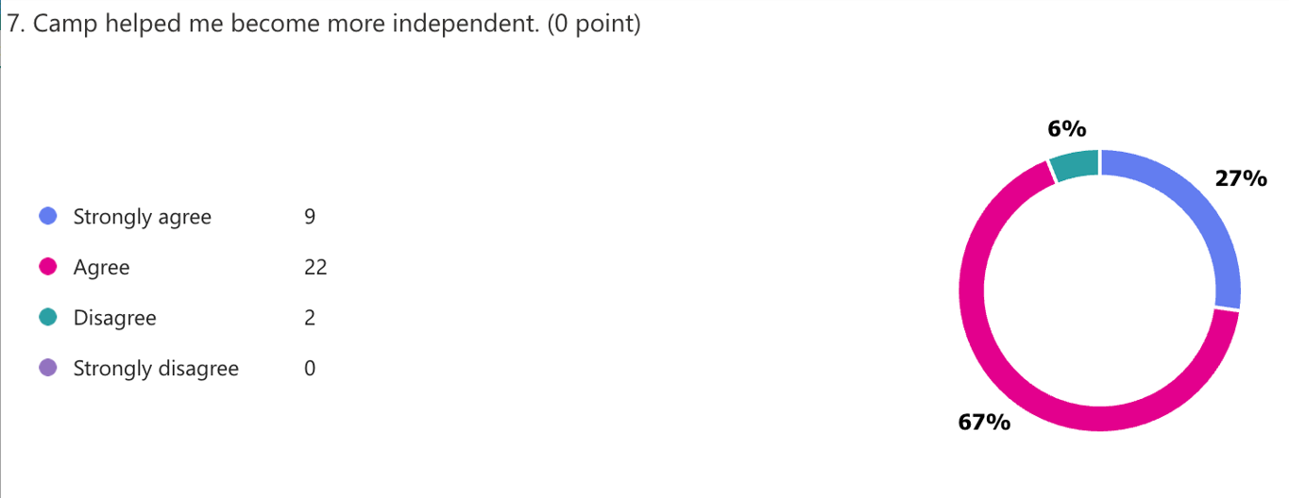
Overall Camp Rating
Student ratings reflected the success of the experience:
- 87% rated camp as Exceptional or Above Average
- 45% rated camp Exceptional
- Only one student rated camp below average.
These results reinforce what staff observed throughout the week: students embraced challenges, supported one another and demonstrated remarkable resilience and maturity.
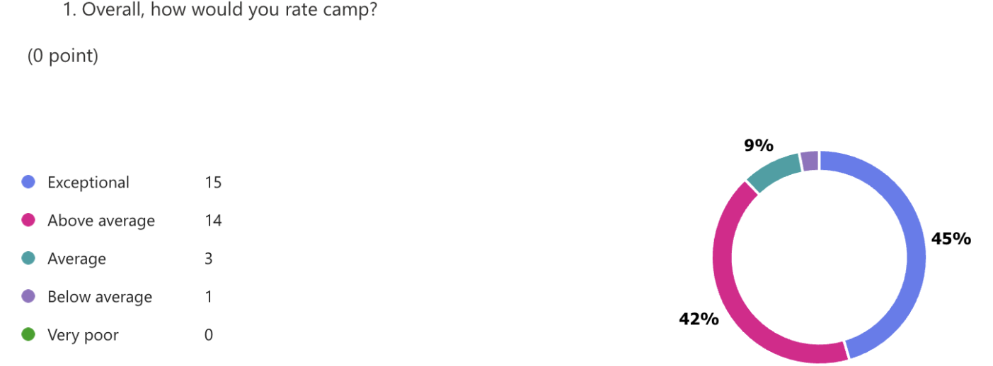
Parent Feedback
Thank you also to the parents who have already completed the parent survey. The feedback received so far has been overwhelmingly positive and appreciative, with many families recognising the growth, confidence and independence their children gained through the experience.
More Than Just a Camp
While camps are not a mandatory part of schooling, they remain one of the most valuable experiences we can offer students. They provide opportunities for personal growth, teamwork, resilience, independence and lifelong memories that simply cannot be replicated in a classroom setting.
Thank you again to our students for their enthusiasm, our families for their support, our P&C for their generous contribution, and the staff who willingly gave up time with their own families to make this memorable experience possible.
By every measure, Camp 2026 was a tremendous success. 🌟
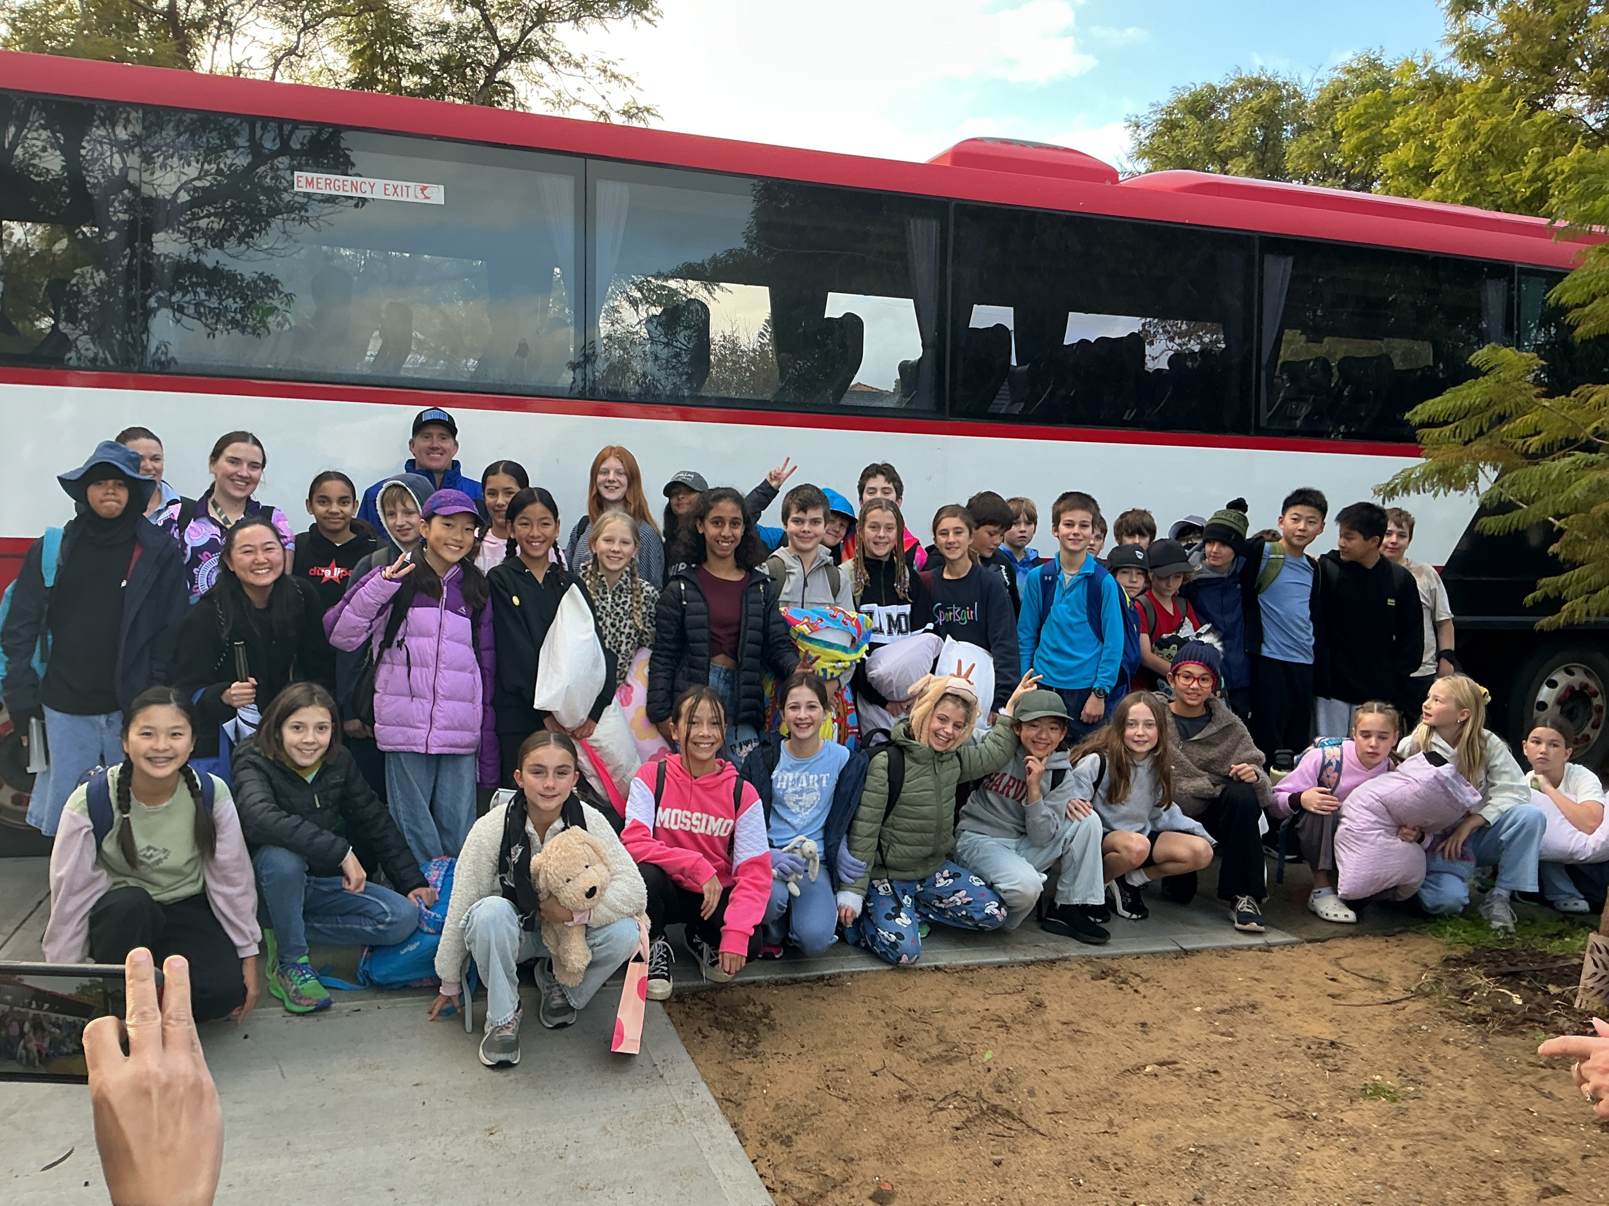
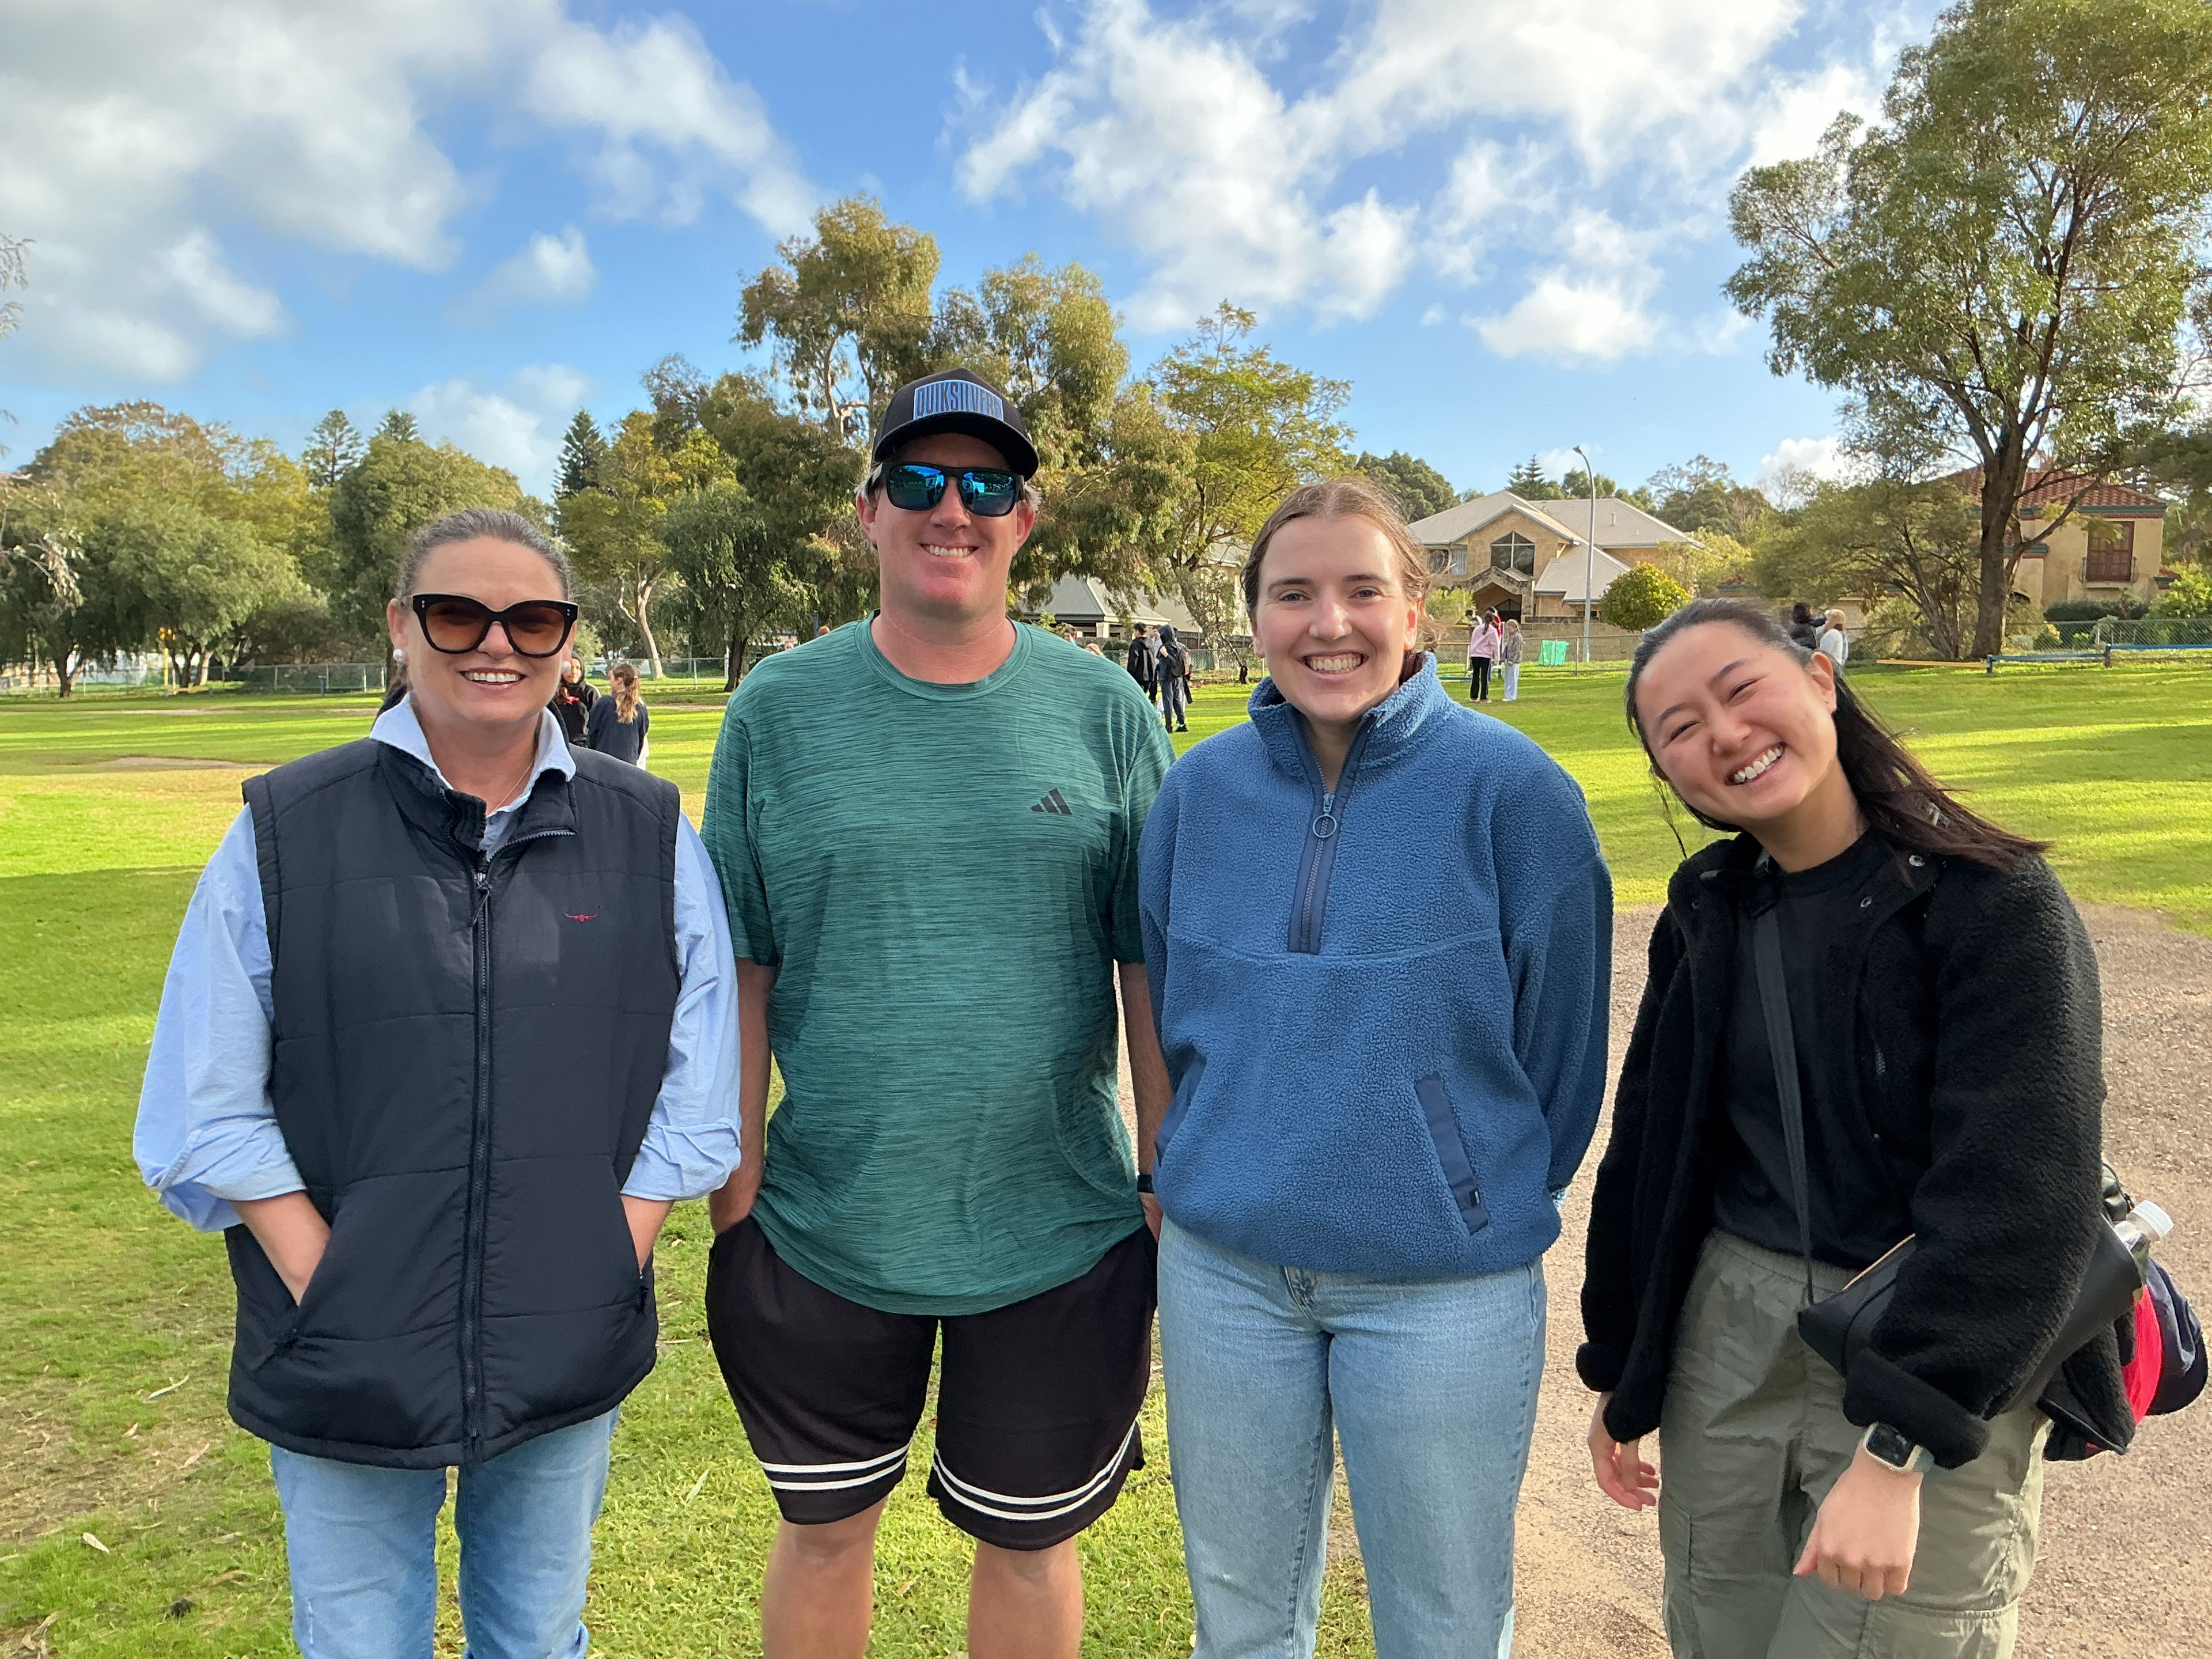

Assembly Rm 18
"Guess the West" Assembly
This week, Room 18, Ms Sie's class, proudly presented our assembly, "Guess the West". Students took the audience on a game show adventure around Western Australia, showcasing many of the incredible features that make our state so unique. From famous landmarks and fascinating wildlife to our rich history and stunning natural attractions, students enthusiastically shared their learning while keeping the audience entertained.
The assembly concluded with a beautiful performance of "I Am Australian", led by Mr Gardiner. It was a wonderful way to celebrate our country and reflect on what it means to be Australian.
We are incredibly proud of the students in Room 18 for their hard work, confidence, and enthusiasm. They did a fantastic job and should be very proud of their efforts.
Thank you to our families and school community for your ongoing support.
Ms Ciskia Sie
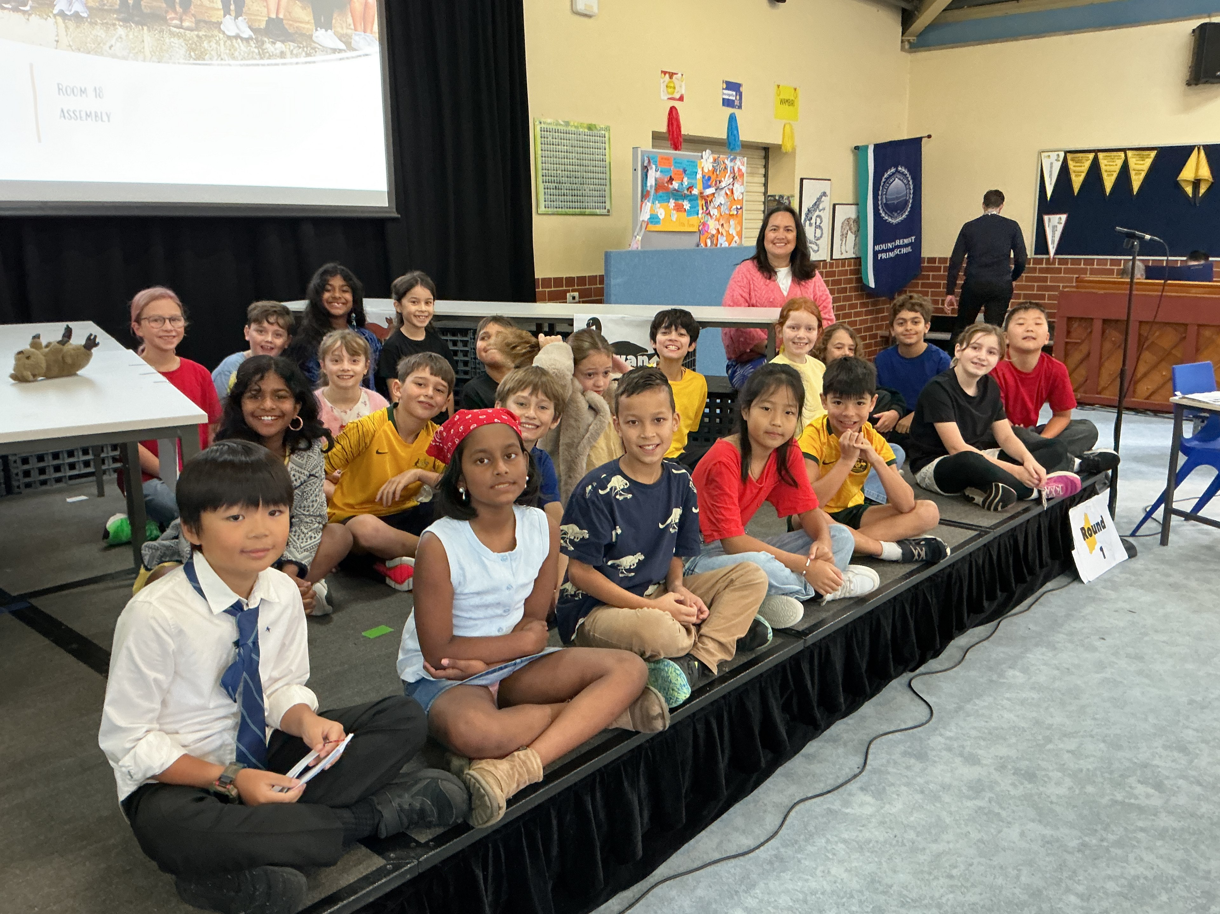

Rising Voices
Rising Voices Public Speaking Competition
As we reach the end of our term-long focus on public speaking, it has been a pleasure for teachers to listen to and assess the many speeches presented by students from Years 1–6. The growth in confidence, communication skills and presentation techniques has been impressive across all year levels.
On Thursday 11 June, we held the Mount Claremont Primary School final of the Rising Voices Public Speaking Competition. Three students from each of Years 4–6 were selected to compete, presenting both a prepared speech and an impromptu speech.
Our finalists were:
Year 4
- Matthew J – Exoplanets
- Cameron T – If Colours Didn’t Exist
- Lily R – Wild Whales
Year 5
- Zoe Z – Is Pizza Healthy?
- Finley N – The Power of Yet
- Flynn B – Broccoli is Evil
Year 6
- Jamie B – The Tudor Era
- Julie T – Sayings
- Nikol V – Magpies
Following their prepared speeches, students were challenged with an impromptu speaking task, having only five minutes to prepare a speech on a given topic. Year 4 students spoke about Kindness, Year 5 students discussed Health, and Year 6 students considered How Should We Use AI? The quality of both the prepared and impromptu speeches was outstanding.
We were also treated to showcase speeches from students in Years 1–3, including:
- Hugo B-S – Imagine a World with No Dogs
- Marco B – How to Get Olives Ready to Eat
- Ava C – Kids Should Rule the World
- Sebastian H – Anacondas
- Isabella W – Impersonating Teachers
- Scarlett J – The Magic Faraway Tree
- Clio N – Frogs
At the conclusion of the competition, we congratulated our year-level winners: Matthew J (Year 4), Zoe Z (Year 5) and Julie T (Year 6). These students will represent Mount Claremont Primary School at the interschool Rising Voices competition at Jolimont Primary School on Monday 22 June.
Congratulations to all students from Years 1–6 for their efforts throughout the term. Thank you also to the families and teachers who have supported students in preparing and refining their speeches. Each year we see a significant improvement in students’ speaking abilities, and it is wonderful to watch them develop a skill that will benefit them throughout their lives.
We look forward to Rising Voices again next year.
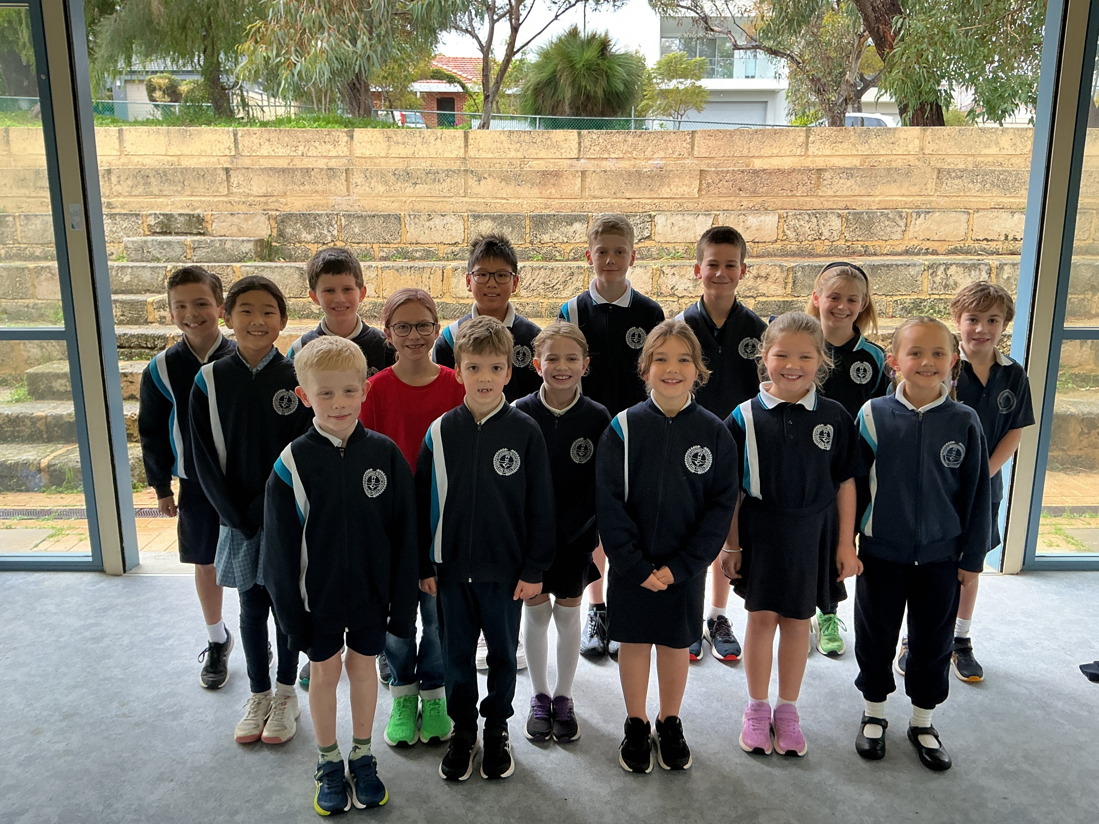

Maths Olympiad Update
Last week, on 10 June, Mount Claremont Primary School students participated in the second Maths Olympiad contest for 2026. Once again, students were challenged by a diverse range of problems that tested their skills in fractions, logic, divisibility and mathematical reasoning.
A highlight of this contest was students tackling their first cryptarithm, a puzzle where numbers are represented by letters and logical deduction is required to find the solution. Many students enjoyed the challenge and demonstrated impressive perseverance when working through these unfamiliar problems.
After the first two contests, the competition remains extremely close. We currently have five students tied for first place: Hansu Wu, Matthew Jiang, Jackson Heggie, Annabel Dalrymple and Dante Dong. Congratulations to these students on their outstanding performances so far, and well done to all participants for their effort and enthusiasm.
We look forward to seeing how the competition unfolds in the remaining contests throughout the year.
Tom Cecins

Early Childhood Lake Claremont Excursion
On Tuesday 9th, 65 Kindy and Pre-Primary children rugged up in their raincoats and headed out to our local Lake Claremont with the help of our wonderful parent volunteers.

Once there, the children used collection bags to hunt for natural treasures from their surroundings. They then used their finds to create beautiful nature patterns. It was a fantastic hands-on experience.

A huge thank you to all the parents who gave their time to help out this term, excursions like this simply wouldn’t be possible without you. We look forward to more adventures next term!

ECE Team
🌿 Lake Claremont Excursion
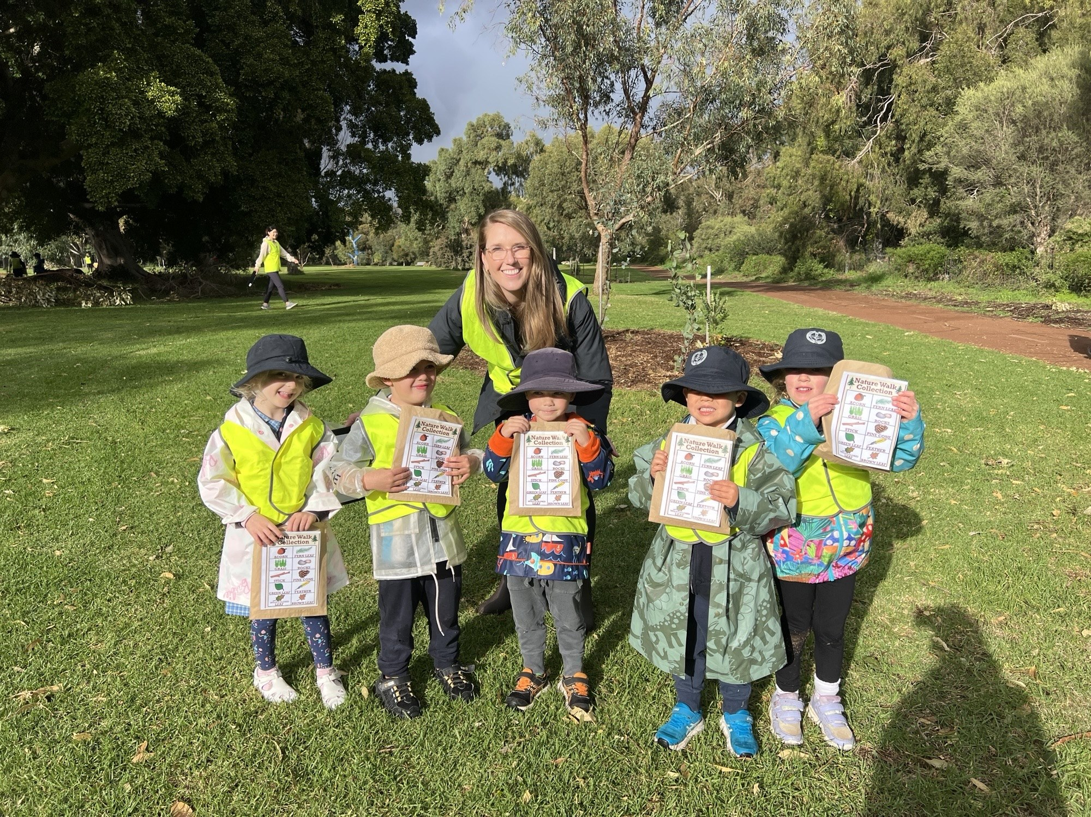

Jiggle Jam - Kindy

Jiggle Jam ~ Music & Movement with our Kindies!
Each fortnight, our Kindy children have been taking part in Jiggle Jam, a music program designed for children in the early years.
Each class brings together music, movement and story in a play-based format, with a new theme, songs, instruments and props each session.
The children have been exploring beat keeping, rhythm and pitch recognition, tempo and solfa singing. Each fortnight with Miss Catherine and Tahlia they get hands-on with different instruments, building their understanding of beat and rhythm in a fun, active way.
Singing games are used throughout each session to develop aural skills, with solfa (do, re, mi…) introduced to explore tonality and build confidence. Beyond the music itself, the program also supports listening skills, pattern recognition, language and speech, body awareness, coordination, and confidence.
We have loved our lessons and look forward to our final two sessions in Weeks 9 and 11 🤩

Mrs Donaldson

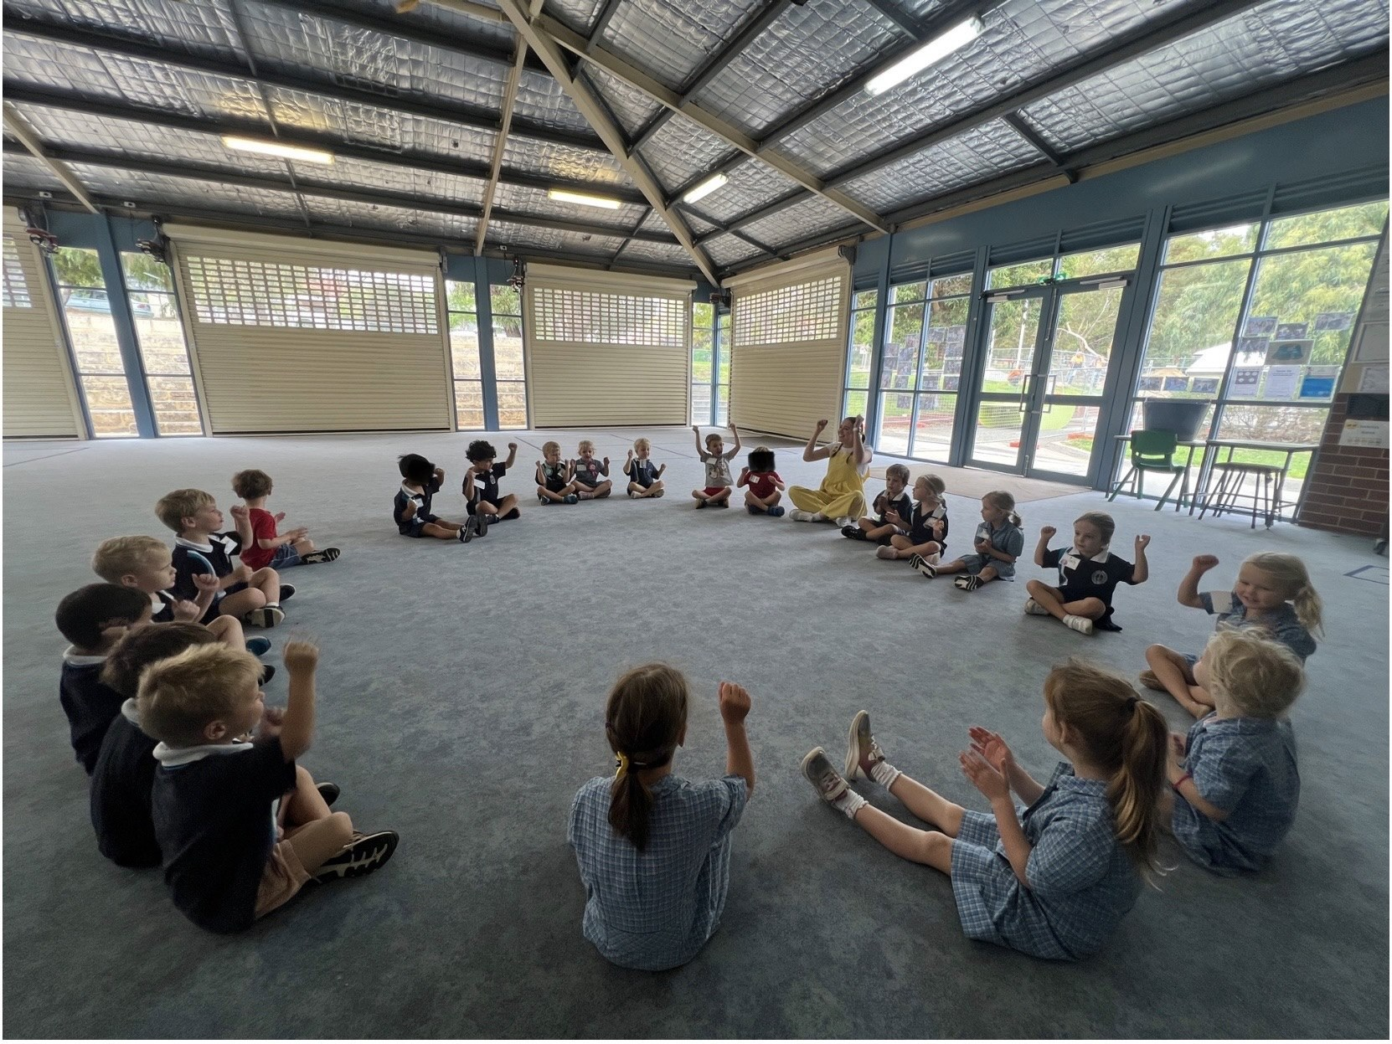

Cross Country Faction Carnival
Congratulations to all Year 3-6 students for their efforts at the recent Faction Cross Country carnival, it's always an extremely tough event but all students should be very proud of how they met the challenge head on. A big thank you must go to our fantastic faction captains for their assistance in running the carnival, and to all parents who came along to support our competing students.
Congratulation to Nyanda, our 2026 cross country champions!
Nyanda - 193, Boogalla - 167, Wambiri - 148
The top 5 students from each event qualify for the MCPS Interschool Cross Country team, good luck to our team who'll be competing at Harvey Field, Cottesloe on Friday 26 June from 10am-1pm.
Mr Brad Staples
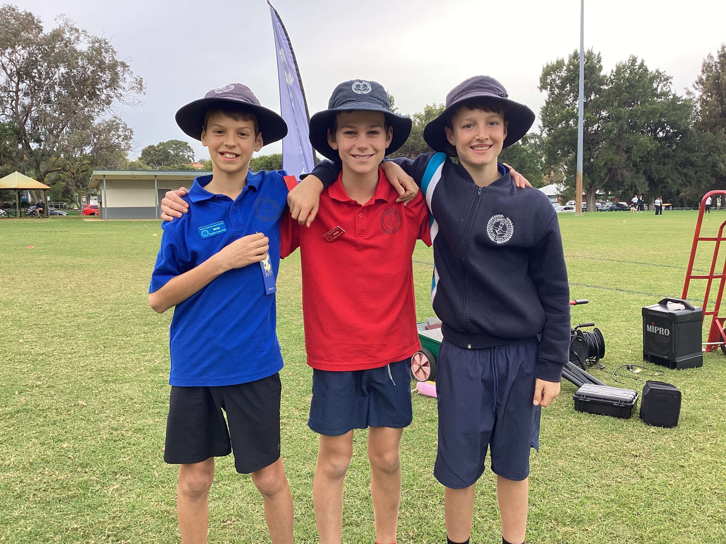

Choir & Band News
Band
OPUS Workshop reflection:
On Tuesday the 9th of June, the band students went to Lake Gwelup Primary School to practice for the OPUS Concert, where the Big Band Strawberry Jam will perform Space Adventure, which is a 4-movement song.
Once we got there, we set up our instruments and sat down in our school groups. Soon after that our instrument groups got areas to sit in; Flutes at the front on the left, Clarinets at the front and second row on the right with Bass at the end, Guitars second row on the left, Trumpets in the middle of second row and the left side of the back row, and Low Brass on the right side of the back row. The Mount Claremont Band is the only band with glockenspielists, a bass player, and a baritone player.
We practiced Space Adventure a couple of times together as a whole with Mr. Pointon and Ms. Burke. Mr. Pointon is one of Western Australia's most prominent instrumental music educators, clinicians, and conductors. He is highly regarded across schools, universities, and community music networks in Perth. Ms Burke is our conductor for the concert and teaches at Lake Gwelup PS.
Then we split up into our instrument groups. Brass and Bass had Mr. Simpsons, an IMSS teacher who formerly taught at MCPS. At the end we performed Space Adventure a couple more times and my mouth was aching.
Playing with other low brass players helped me understand the parts of the song I did not understand. Overall, we improved a lot as a band and we sounded brilliant. I really enjoyed the whole experience and thought that the whole thing was enjoyable and incredibly helpful.
By Karen M
The 2026 Instrumental workshop was at Lake Gwelup Primary School was a significant event. Bands from other schools all united to create the Big Band Strawberry Jam. Mr Pointon, a very experienced conductor, led us through the workshop with some extremely helpful advice. We practiced a four song piece called Space Adventure by Bill Mc Allister, showing four experiences in space. The experience was wonderful and I learnt so much for the upcoming Opus concert. The amazing Ms Bourke will be our conductor at the Opus concert. The Big Band Strawberry Jam improved so much.
By Vernica A
Congrats to all band students on their excellent efforts and behaviour at our OPUS workshop and Assembly performance in Week 8. Very proud of how it went. We need to remain focused and practice our Band material, in particular focus on staying in time and not rushing through Journey into the Unknown.

Tech Rehearsal Monday June 29 - students will need to wear school uniform and bring all their instrument requirements, music folder, recess, lunch and water bottle, hat and bag, pencil and eraser. Student will need to be at school at 7:55am to leave at 8:10am. We will arrive at Lake Gwelup PS at approx. 8:40am, rehearse, then leave for Perth Modern at 11:00am to arrive at 11:30am. We will then run a tech rehearsal and leave at 1:15pm to arrive back at school at 1:45pm.
OPUS Concert Monday June 29 - student will need to bring all their instrument requirements, music folder and waterbottle (no bags or hats). Please eat a substantial meal before arriving. Students are to wear Leavers shirt (please don't wear it during the day!) black pants, socks and shoes.
If you do not have these please ask others in the school community if you can borrow, lots of choir students should have black pants and shoes. Jeans are fine but no leggings please. The school has spare shoes if needed but might be too small for larger feet. No large bows or head pieces, jewellery or items of clothing that may draw attention please. School coloured headbands or lackeys would be preferred.
Students need to arrive at Perth Modern (dropoff location TBC) between 5:15pm and 5:30pm.
Concert doors open 6:30 for a 7pm start, ticket info and Parking info was sent in previous Compass notices.
Students are to be collected at Interval (approx. 8pm-8:15pm). If someone other than a parent is collecting your child can you please let me know ASAP.

Choir:
Congrats to Summer Le and Annabel Dalrymple who have been selected to represent the school at the solo and compere auditions for Massed Choir Festival next term. All the students who auditioned were amazing and had put in lots of practice, making it a very tricky decision! Thank you to all parents for your assistance.

We will be performing Away from the Screen at the first assembly of Term 3 in week 3 so please focus on this along with all the other MCF songs. Most students should begin practicing the songs we have focused on at school against the Side 2 vocals or with the backing track songs, concentrating on singing our part and not the other side's parts!
Mr Gardiner
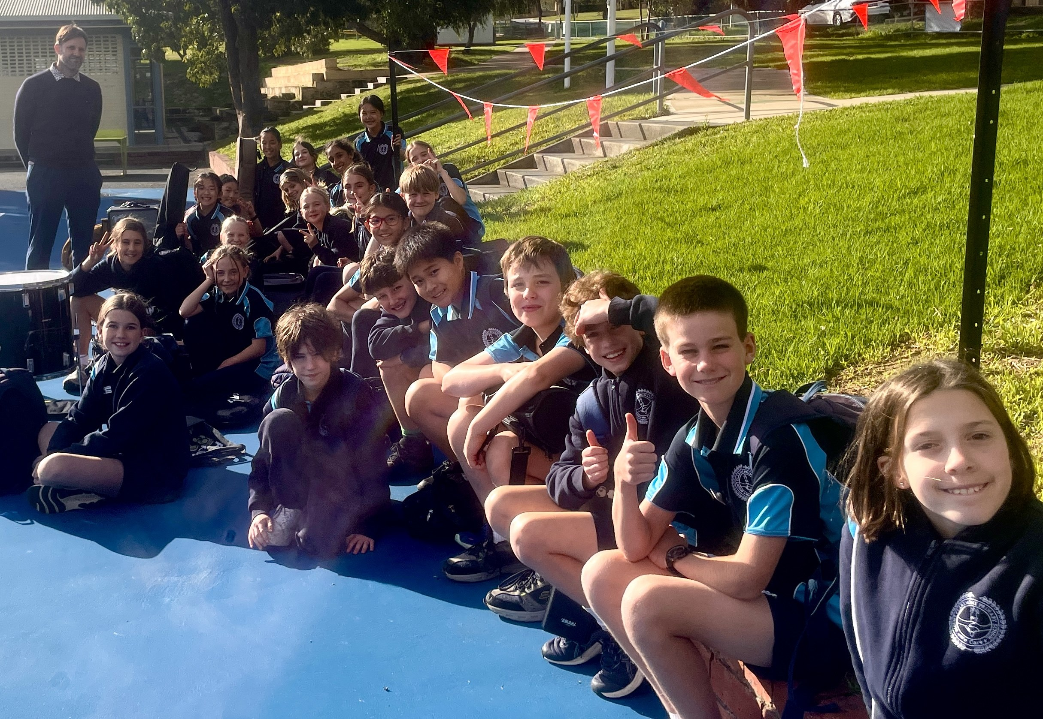

Year 6 Art Success
Year 6 Room 6
Watercolour Success
Miori T has demonstrated outstanding talent as a watercolour artist through her recent Visual Arts assessment. Following a series of explicit lessons exploring watercolour techniques such as blending, layering, colour washes and detail work, students were challenged to create an artwork featuring an endangered or at-risk animal while highlighting the impact of humans on the natural environment. Miori embraced the task with creativity, skill and attention to detail, producing a thoughtful and visually striking piece that perfectly captured the assessment brief. Her artwork showcased both strong artistic technique and a clear understanding of the environmental message behind the task. Congratulations, Miori, on an exceptional achievement!
Alexandra Malloch
Year 6 Class Teacher


Parent Interviews July 1 - Bookings Close June 25 at 3.30pm
Parent Interviews for K- Year 6 will be held on July 1 from 12.00-6.00, there will be a half day school closure for the interviews. Kindy will also be conducting interviews on Tuesday June 30 from 8.45-11.30.
Parent Interviews -Online Bookings are now open so please book a time online.
Go to www.schoolinterviews.com.au and enter the code: ud5fk
- Enter your details
- Select the teachers you wish to see
- Select the appointment times that suit your family best
- When you click FINISH your selected bookings will be emailed to you immediately. If you do not receive your email, please check your junk-mail, or enter the event code again and check your email address spelling.
- Update your details if the email address is incorrect.
- DO NOT DELETE the email you receive. Keep it somewhere safe. You may need to refer back to it at a later date. Please do not contact administration or the class teacher to make an appointment with your child's teacher, it must be done through School Interviews.
- Bookings will be closed on 25 June at 3.30 pm. Interviews are 10 minutes only.

Libby Johnson
Deputy Principal


Theircare 1 July - Open from 12 noon

Theircare open for bookings on 1 July - School Closure for parent/teacher interviews.
Book at www.theircare.com.au
email info@theircare.com.au or
call Customer Service 1300 072 410

Library Club - Thursdays
Last week in the Library Club, we created fairies from corks, doilies and cupcake holders inspired by Mrs. McCoach's favourite childhood book series “Teddy’s Forrest Friend’s series, by Shirley Barber. Our fab teacher extraordinaire keeps this series in her classroom’s back store. We should indeed remind her to take them home for soon, especially with a baby on the way!
In the meantime, we used a particular fairy in the book, Rosebud to learn about the values of teamwork and helpfulness as she demonstrated working together with her forest friends (and a bit of magic) to retrieve a kite stuck in a tree.
On Thursdays during Library Club, participants can either play games or engage in activities with the other children, sometimes with Mrs Marsh and sometimes with Mrs Dalton. Hudson B often takes on the role of leader and mentor, and this time he was responsible for gluing the cork fairy heads onto the doily bodies of our creations.
As you can see, our fairies resembled Rosebud, a character from Mrs. McCoach's childhood books. We even managed to make some of our fairies "fly" using string!
Every Forest friend and school child could use a bit of fairy magic, especially when kites get stuck in trees.
Claire Dalton
Defence Force Mentor
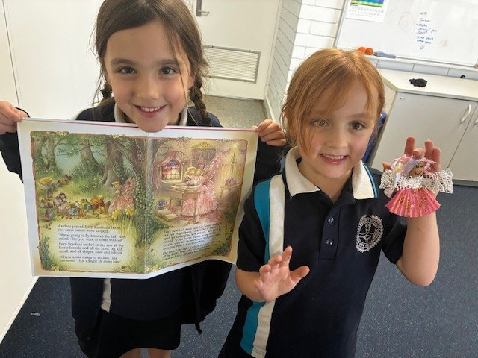

P&C News

The P&C were really pleased to fund new choir shirts and band equipment for the school's music program this term, as well as supporting a group of students to attend the Opus Workshop. Funding these activities helps to keep costs down for parents and make sure that music is an accessible extra curricular activity for all children. We're also excited to be expanding the Beast Training program on Thursday afternoons to include Years 1 and 2 children from Term 3.

We're on the hunt for a new Chair of the Farmer's Market Committee. The Chair oversees decisions made about the market including providing a sounding board for the Market Operations Manager (an external role) and being the conduit between the Market Operations Manager and the P&C. It is not an operational role and doesn't mean you need to be at the market every week. It does mean that you can get under the hood of the business side of things, ensure good governance and influence key decisions about how it operates. If you think you'd like to hear more, please email mtclaremontpc@gmail.com to set up a confidential chat with the current Chair. Go on!

Angela Tyrrell
P&C President

Edu Dance Concerts

A reminder to families that our Edu-Dance Concerts will be held next week, with two performance days to showcase our students’ hard work. Each concert will begin at approximately 2:15pm and will be held in the undercover area. Edu-dance requested 2 performances because we cannot have everyone performing on one concert.

Tuesday Concert - 23 June at 2:15pm
PP – Room 15
Yr1 – Room 14
Yr2 – Room 12
Yr3 – Room 9
Yr 4 – Room 18
Yr 6 – Rm 5
Thursday Concert - 25 June at 2:15pm
PP – Room 17
Yr1- Room 13
Yr2 – Room 11
Yr3- Room 10
Yr4/5- Room 2
Yr5 – Room 3
Yr6- Room 6

We encourage families to come along and support our students as they take to the stage and proudly perform what they have been learning. It promises to be a fun and entertaining celebration of dance and effort!
More details will be shared closer to the date. We can’t wait to see you there!

Mrs Hollier
Teacher, Dance Coordinator

EduDance Costume Suggestions
*Dress Rehearsal week before concert if possible, please *
The following list is a recommendation for costumes
This list is very negotiable so please let us know if you have any other ideas or questions.

Merit Awards Week 8
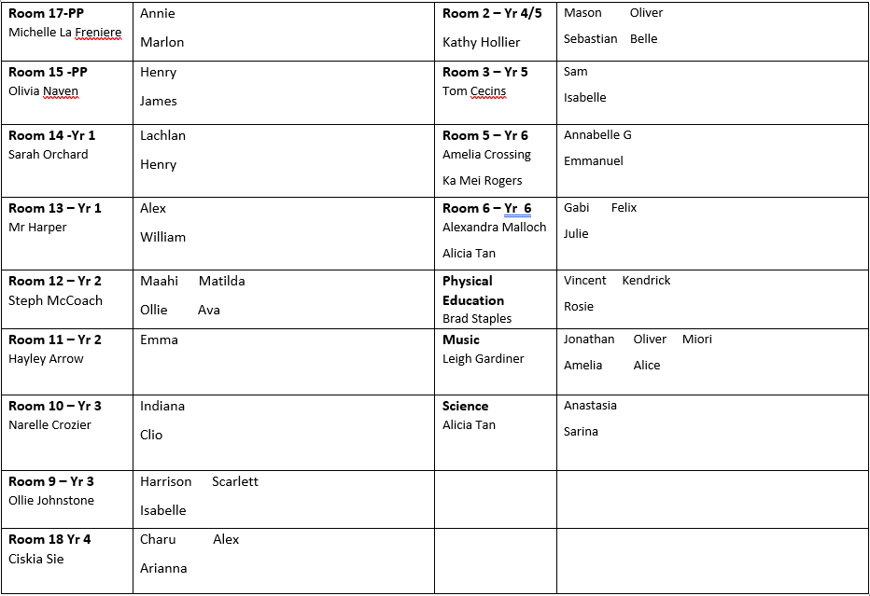

Kindergarten Enrolments 2027 are now open!
All children born between 1 July 2022 and 30 June 2023 are eligible to start Kindy in 2027.
Applications for Enrolment forms are available on the MCPS website or from the Office. We would appreciate it if you could complete your application forms as soon as possible.
Closing date for enrolments is 24 July 2026.

School Watch

Did you know there’s a hotline dedicated to keeping WA public schools safe? It’s called School Watch, and it’s here to help protect schools from vandalism, theft, and damage - especially during the holidays and weekends when schools are empty. If you see something unusual near a school like suspicious vehicles, loud banging, or groups hanging around, make the call:
School Watch Security: 1800 177 777
WA Police: 131 444

Wellbeing for Parents
Days seems to flow by busily and sometimes life can be a juggle with many conflicting demands. The following article by Jen Sandil on finding balance in daily life, are some recommendations that pocket small moments of mindfulness and self care.

Finding Your Balance: Sustainable Daily Habits for Busy Adults and Parents
18/02/2026 | Jen Sandil
Parenting young children is often described as a rewarding journey, but it is also one that can feel fast-paced and occasionally overwhelming. When your days are filled with meeting the needs of others, finding a sense of calm and balance can feel like a distant goal.
However, mental wellbeing for parents is not about achieving a perfect state of Zen or adhering to a rigid, hour-by-hour schedule. Instead, it is about creating small, sustainable “anchors” throughout your day that help you feel grounded.
A neuroaffirming approach to daily life, means recognizing that every parent’s capacity and sensory needs are different. Rather than adding a long list of “shoulds” to your to-do list, we focus on rituals that respect your energy levels and provide predictability in the middle of the beautiful chaos of family life.
The Difference Between a Routine and a Ritual
We often talk about “routines” when it comes to parenting, getting shoes on, packing lunchboxes and managing the bedtime shuffle. While routines are functional and necessary for a household to run, “rituals” are what support our mental health.
A routine is something you do because it needs to get done. A ritual is something you do with intention and awareness. For example, drinking your morning coffee while scrolling through emails is a routine. Drinking that same coffee while sitting by a window and noticing the temperature of the mug in your hands for two quiet minutes is a ritual.
By adding intention to small moments, you signal to your nervous system that you are safe and present. This shift from “doing” to “being” is a powerful tool for maintaining balance when the demands of parenting feel high.
Finding Time for Yourself in the Chaos
One of the most common challenges for parents of young children is the feeling that there is simply no time left for self-care. It is helpful to reframe self-care away from grand gestures — like a weekend away — and toward “micro-habits.”
Finding balance often involves identifying the “pockets” of time that already exist in your day. This might be the five minutes after the kids are buckled into their car seats before you start the engine, or the transition time between finishing work and entering the house.
Rather than trying to find a whole hour for yourself, look for these tiny gaps. Using these moments for a brief sensory check-in or a few deep breaths can help prevent the “layering” of stress that often leads to parental burnout.
Simple Daily Habits to Improve Mental Health
Establishing daily habits for mental health works best when they are tied to things you are already doing. Here are a few evidence-informed ideas that fit into a busy family schedule:
● Mindful Transitions: Use the moments between tasks to reset. When you move from “parent mode” to “work mode,” or vice versa, take thirty seconds to stretch or notice three things you can see and hear. This helps your brain register that one task is over and another is beginning.
● Sensory Grounding: Parenting young children is a high-sensory experience. If you feel overstimulated, try a cold water splash on your face or stepping outside to feel the air on your skin. This simple habit can help regulate your nervous system.
● Shared Quiet Time: Create a habit where the whole family engages in a low-demand activity at the same time, such as looking at books or drawing. This models healthy regulation for your children while giving you a moment of relative quiet.
● Reflective Ending: Before sleep, identify one small thing that went well today. In the thick of parenting, we often focus on what went wrong. Intentionally noting a success, no matter how small, helps build a more balanced perspective of your day.

Volunteer to be a Puppy Raiser with Guide Dogs WA


Term 2, 2026
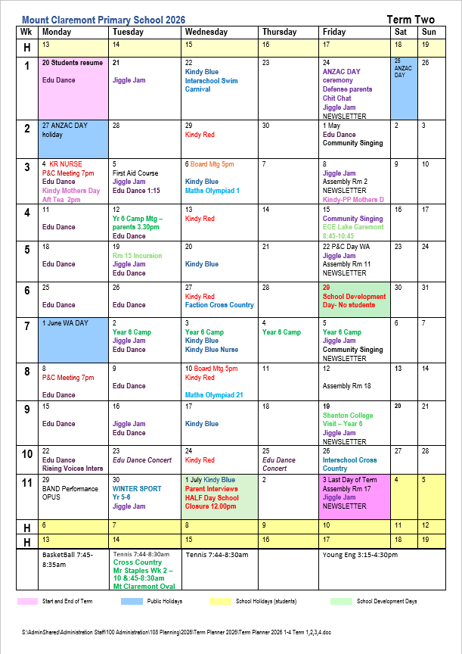

Term 3, 2026
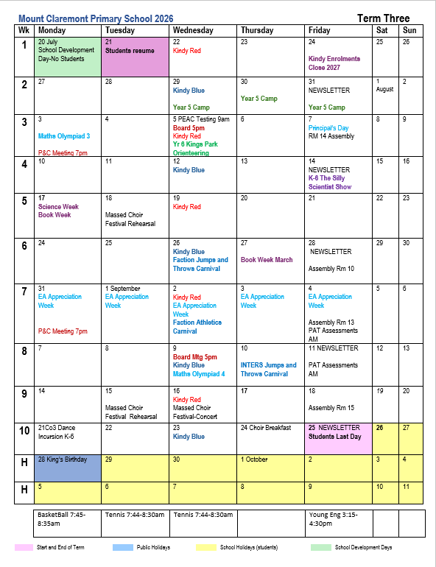

Mount Claremont Farmers' Market

We are looking for your support – Set-Up Crew – Farmers Market (4 shifts per year!)
The Mount Claremont Farmers Market is looking for two parents who are keen to be rostered on just 4 times per year to help set up chairs and tables for the market.
Each shift starts at 6:30am and you’ll be done by around 7:00–7:15am, making it a quick and impactful way to contribute.
The following shifts are available 29,8, 19/9, 21/11, 28/11 and 12/12 and we would love to have them filled. The new roster will then start Feb 6, 2027.
Plus your child is guaranteed shifts on the parking roster once they reach high school earning some good pocket money and staying connected to our community. Your support makes a huge difference in bringing our market to life each week. Join our dream team of local changemakers: Anna, Drew, Justine, Kristel, Lim, Nathan, Ayana and Henry.
If you’re keen to get involved and support our community, we’d love to hear from you! Contact Mica, Market Manager on admin@mtclaremontfarmresmarket.com.au / 0410 199 278
Mt Claremont Farmers' Market opens 7:30am -11:30am every Saturday, no matter the weather, and it's a great start to your weekend. All the regular fabulous stalls and special occasional stalls make for a vibrant, lovely community vibe.
Parking available off Jacaranda Ave for a small donation.
Come down, bring your friends and family and support our wonderful school.

#MtClaremontFarmersMarket #FreshProduce #FoodieHeaven #SaturdayMarket #CommunityMarket #FarmFresh #buywesteatbest #perthisok #perthfoodies #supportlocal #supportfarmers
Mount Claremont Farmers' Market

Theircare - outside school hours care
We apologise for this break in transmission.....
Please be advised, as of today, we have resumed our usual before and after school care service.
But seriously, from the bottom of my heart, thank you to everyone who sent an email, or signed a petition, or generally made their feelings known about my sudden departure; your voices were heard. I am truly overwhelmed by your support and am profoundly grateful to be 'home'. Feel free to pop by and say hi, and I can't wait to see you all soon. Sincerely, Glenn ❤️
Glenn Hall
Coordinator | Mount Claremont PS
0481 060 089
Mentor Coordinator | WA-5 Region
0466 582 133

... Information at MCPS ...
www.mountclaremontps.wa.edu.au
On our website you will find out about:
- Uniforms
- Newsletters
- School lunch orders
- The role of the MCPS P&C Association; and
- Mount Claremont Farmers’ Market.
Our school times are:
First Bell 8:45am
Morning Recess 10:45 – 11:05am
Lunch 12:35 – 1:15pm
Dismissal 3:05pm, 3:00pm in Kindy
Banking
As MCPS is a cashless school, all payments are made via direct deposit to our bank account (we will invoice you as charges arise).
Bank account - ANZ
BSB 016 281 Account 489992809
Compass
We communicate all correspondence through Compass. Download the Compass App to your phone.
Parking at the school
Please be respectful to our neighbours when parking on the streets around the school and do not park in people's driveways. Please no double parking, only park in designated car parking areas. Please be mindful of damaged areas when parking on the grassed areas inside the school gates.
Please do not park or use the Staff carpark as a kiss and drive area. This carpark is for Staff Parking only.
Driveway, front grass entrance.
This area is NOT an official car park. Please take extreme care with your children when going to and from cars on the grassed area. Students can be dropped off and collected via the "driveway" at the front of the school. The traffic must keep flowing on the driveway. If your child is not at the driveway pick up point, you must move on. You can park on the grass or exit left and do another lap.
Excursions/Permission
Information is sent through Compass. Consent is made online and payments must be made to school bank account.
Medical Conditions
Please update and fill all forms for medications and emergency plans at the administration office.
Health and medication forms must be completed at the office by parents for students requiring long and short-term medication (antibiotics) to be given during school time. Only medication in original packaging will be accepted.
Please do not hesitate to contact the office if you have any questions or concerns.
Ph: 9208 3900

Our P&C Members
Angela Tyrrell, President
E: mtclaremontpc@gmail.com
Ariel Jin, Treasurer
Emma Tomczak, Secretary

Uniform Shop

The Mount Claremont Primary School Uniform Shop is volunteer run and open Tuesdays and Thursdays from 8:30am-9:00am. We have a new and second-hand items for sale. Uniforms may be ordered online and picked up at the Uniform Shop when it is open. We welcome all clean and useable donations.
Regular opening Hours:
Tuesdays: 8:30 – 9:00am
Thursdays: 8:30 – 9:00am
Online: mcps-uniforms-shop.square.site
Contact: uniformshop@mountclaremontprimaryschoolpandc.com


After School Activities

Young Engineers
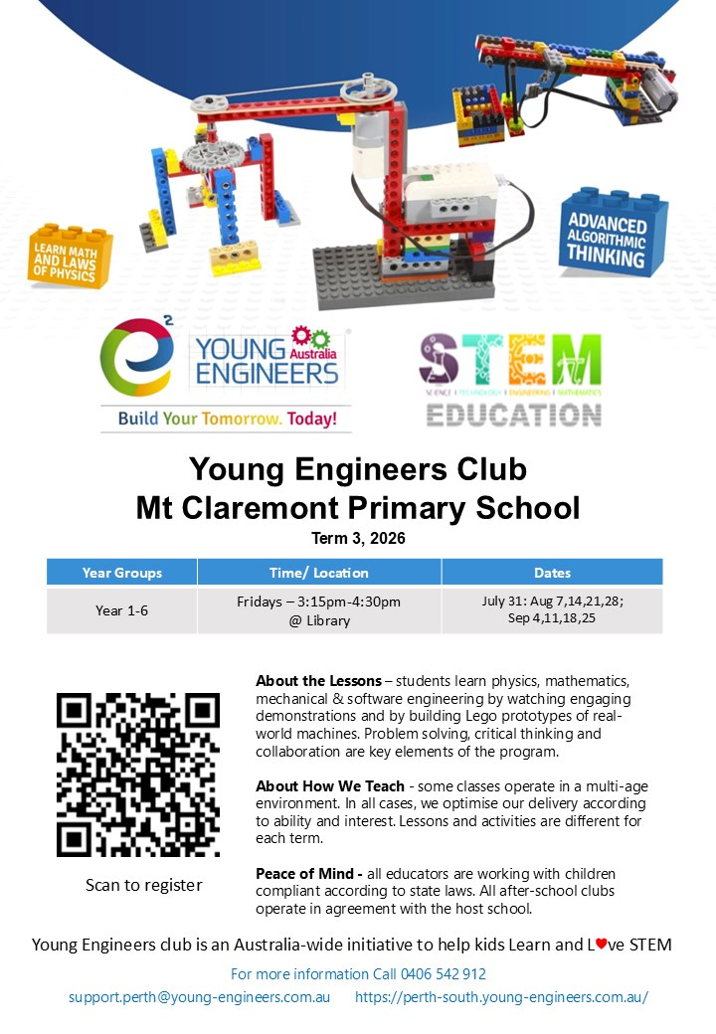

Redhage Basketball


Prime Tennis
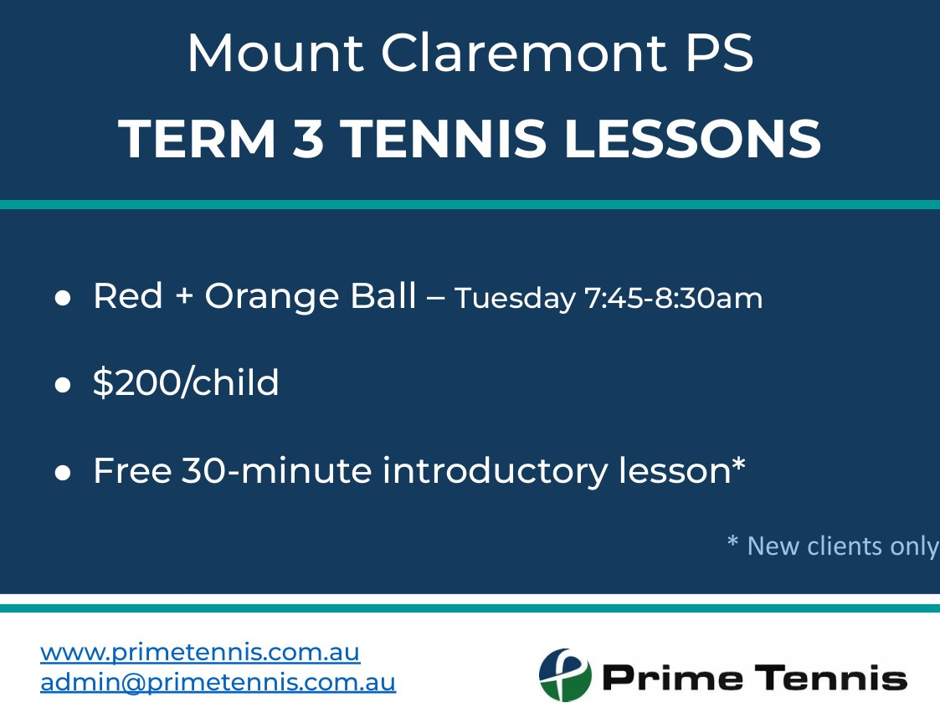
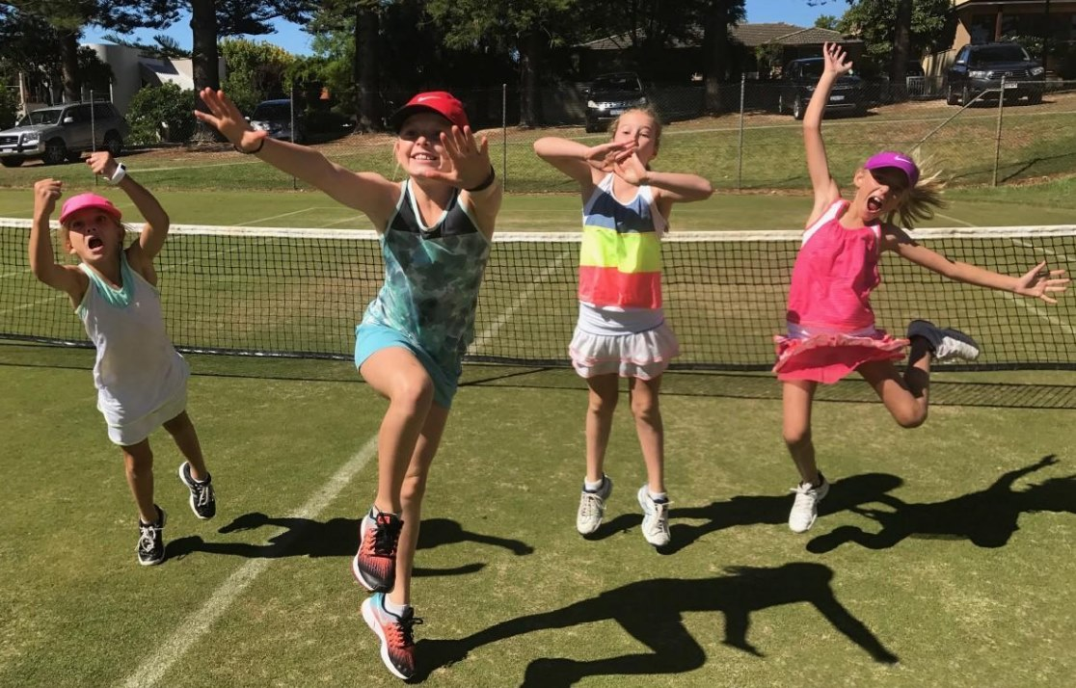

Holiday Activities


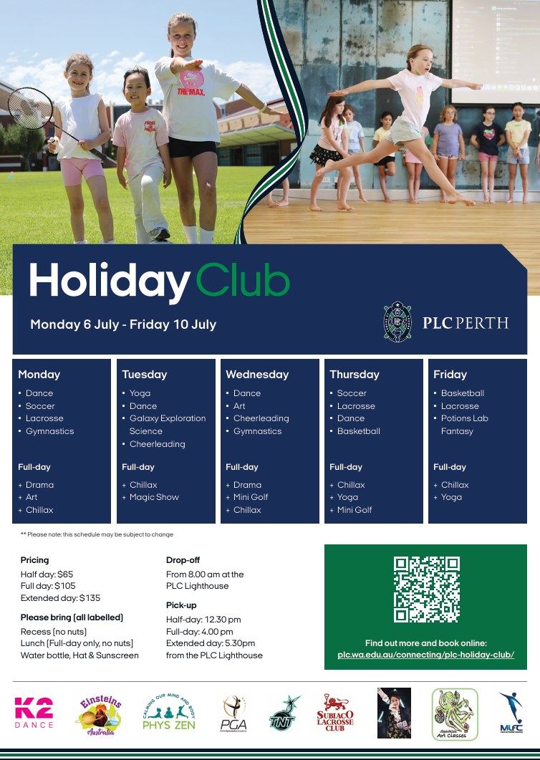

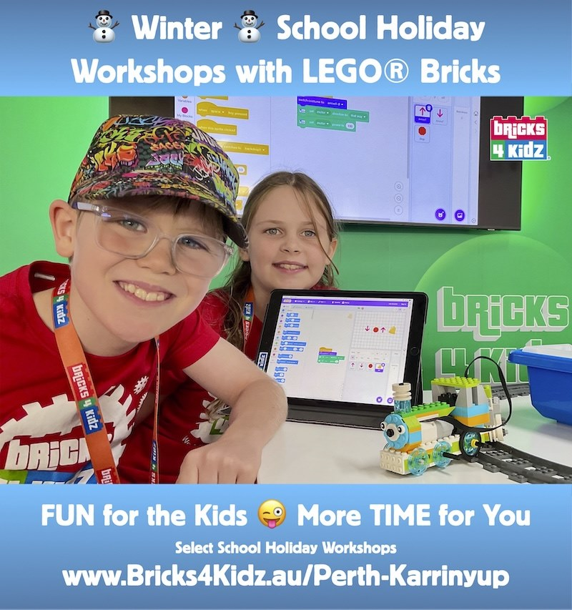




Helping Minds - Free Wellbeing Program
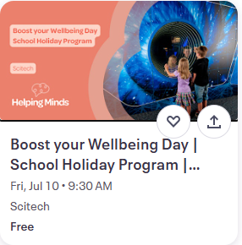
Overview
Free 1-day, school holiday program for young people aged 7 to 12, focused on building resilience, confidence and boosting your wellbeing.
Boost your Wellbeing Day | School Holiday Program
Boost your Wellbeing Day is a one-day therapeutic School Holiday Program designed for young people aged 7-12. Spend the day with us exploring different ways to Boost Your Wellbeing, while exploring the Scitech and engaging in activities and conversations with others.
Day Out
This program includes a supported excursion to Scitech, which is intentionally designed as part of the therapeutic program.
The excursion provides opportunities for young people to:
- Practice social skills in a real-world setting
- Build independence and confidence outside the home
- Strengthen peer relationships in a safe, supported environment
- Apply emotional regulation and coping strategies learned during the program
When: 10 July - 9:30 am - 3:30 pm
Who: Young people aged 7-12
Where
Scitech
What to Bring
✔ Hat
✔ Sunscreen
✔ Water bottle
✔ Enclosed shoes
Interested? Book here

Contact Us...

Mount Claremont Primary School
103 Alfred Road, Mount Claremont WA 6010
Phone: (08) 9208 3900
ABN 43 016 297 121
mountclaremont.ps@education.wa.edu.au
Visit us on our website mountclaremontps.wa.edu.au

