Early Childhood Information 2027

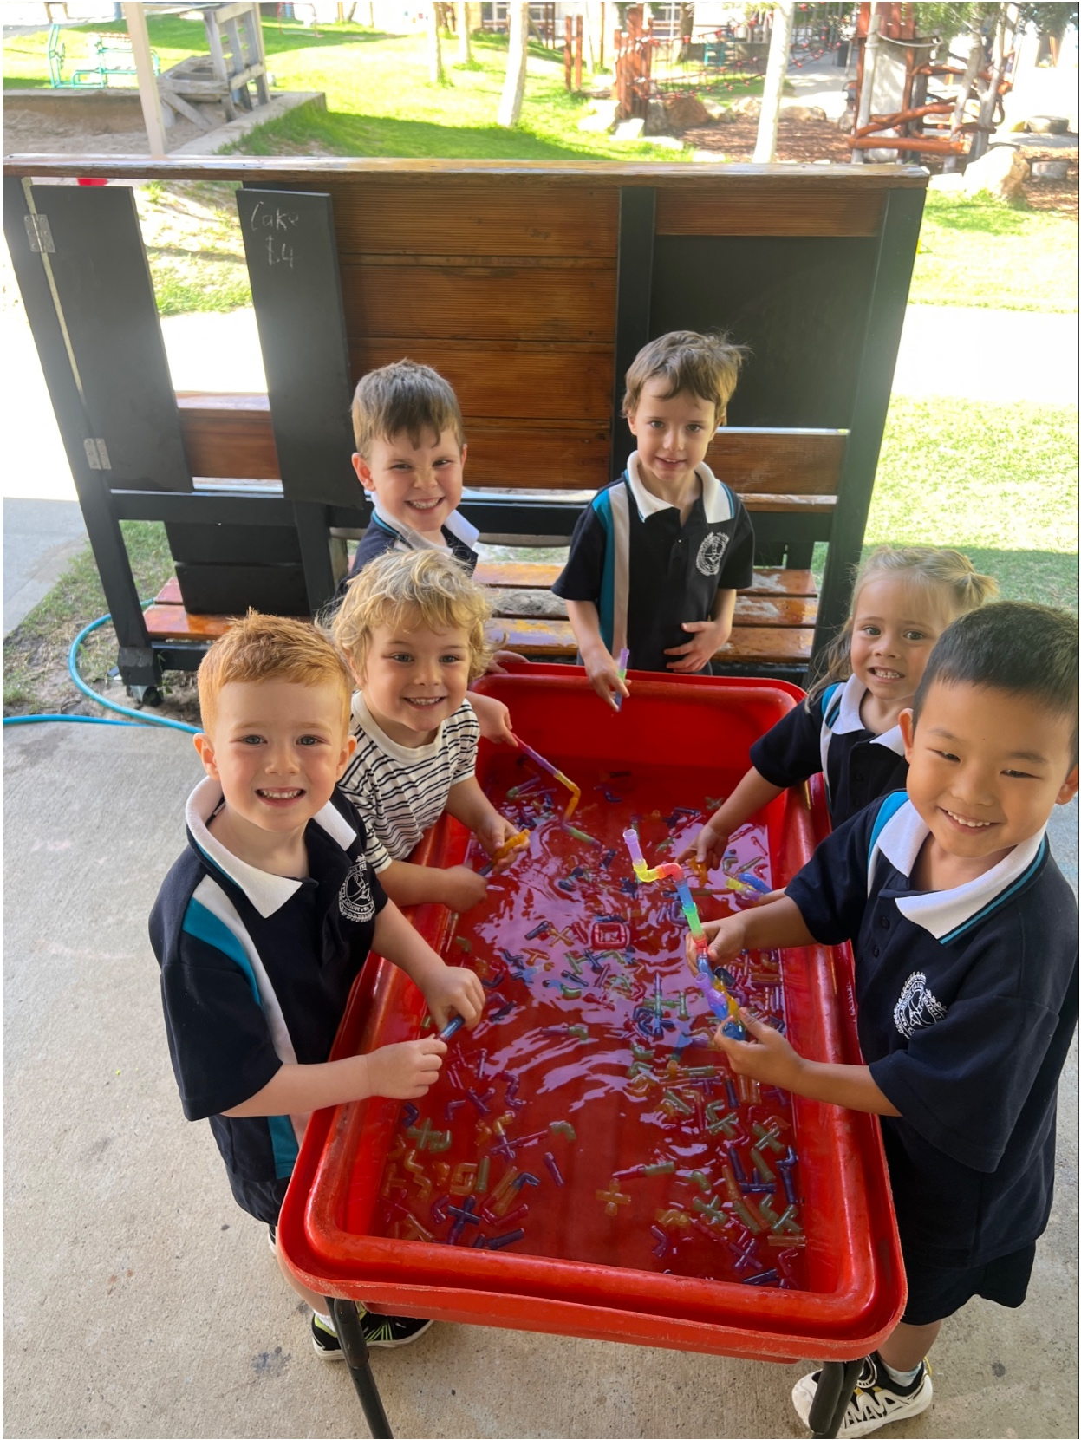
SCHOOL OFFICE DETAILS

Opening Hours: Monday to Friday 8:00am to 4:00pm
Telephone: (08) 9208 3900
Email: mountclaremont.ps@education.wa.edu.au
Website: https://www.mountclaremontps.wa.edu.au
Street Address: 103 Alfred Road, Mt Claremont WA 6010

TERM DATES 2027

Term 1: Monday 1 February – Friday 9 April 2027
Term 2: Wednesday 28 April – Friday 2 July 2027
Term 3: Tuesday 20 July – Friday 24 September 2027
Term 4: Monday 11 October – Thursday 16 December 2027

STARTING DATES KINDERGARTEN AND PRE-PRIMARY

Kindy Red: 1 February 2027
Kindy Blue: 4 February 2027
Pre-Primary: 1 February 2027

SCHOOL DEVELOPMENT DAYS, PUPIL FREE 2027

Term 1 Thursday 28 January and Friday 29 January, students start Monday 1 February
Wednesday 31 March – Parent Teach Interviews – No school for students all day

Term 2 Tuesday 27 April
Friday 4 June before long weekend – WA Public Day (7 June)

Term 3 Monday 19 July

Term 4 Friday 12 November School Development Day

CLASS TIMES

Doors Open: 8:35am
Siren: 8.45am
Morning Session: 8:45am – 10:45am
Recess: 10:45am – 11:15am
Middle Session: 11:15am – 12:35pm
Lunch: 12:35pm – 1:35pm
Afternoon Session: 1:35pm – 3:00pm
Kindy Pick Up: 3:00pm
Pre Primary Pick Up: 3:05pm

Red Group: Monday, Tuesday every week, Wednesday week 1 each fortnight

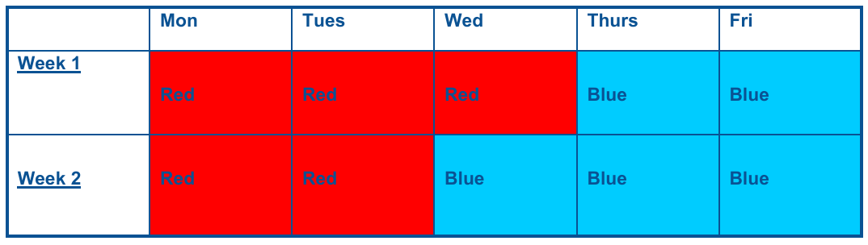
Blue Group: Thursday, Friday every week, Wednesday week 2 each fortnight

The Early Years Learning Framework (2010) states that; “Childhood is a time of belonging, being and becoming”.
“Belonging is the basis for living a fulfilling life”
When children have positive relationships with family, culture, community and place, they are able to feel that they belong. While the child belongs in our class family, so too does their family at home. We encourage all family members to play an active part in our learning program.
“Being is about living here and now”
We foster the use of every minute in Kindy and Pre-primary, often engaging with children on the spot, being led by their observations on life. Children need time to just ‘be’ – time to play, have lots of fun, engage with their friends and try new things.
“Becoming is about the learning and development that young children experience”
Your child has already started forming their own sense of identity, which will help shape the type of adult they will become. We provide many fun, happy, exciting, positive, interesting and age-appropriate opportunities for your child whilst they are at Kindy and Pre primary. By taking part in these activities, your child will learn many new concepts and develop their own ideas.
WELCOME

Welcome to Mount Claremont Primary School. Entry into school for the first time is an important event in a child’s life. Staff in Early Childhood Education aim to make this new experience enjoyable for children and families. The information in this booklet will be supplemented during parent meetings and workshops at the beginning of the year. We look forward to working with parents as partners in guiding each child’s growth and development in this important phase of schooling.

Tracey Oakes
Principal

EARLY CHILDHOOD
TEACHING STAFF
(Subject to Change)

Kindergarten

Room 16
Kindy Red & Blue

Izzy Donaldson
isobel.donaldson@education.wa.edu.au

Pre-Primary

PP Room 15

Olivia Naven
olivia.naven@education.wa.edu.au

PP Room 17

Michelle La Freniere
michelle.lafreniere@education.wa.edu.au

MOUNT CLAREMONT PRIMARY SCHOOL
EARLY CHILDHOOD EDUCATION PHILOSOPHY STATEMENT

At Mount Claremont Primary School, we believe that Early Childhood Education (Kindergarten to Year 2) is the key to establishing an early love of learning.

We provide high quality teaching and learning programs through a balance of explicit instruction, and play-based learning opportunities.

We are committed to fostering the development of the whole child by providing opportunities for learning through play and intentional instruction to support their academic, social, emotional, and physical growth.

Our team of highly qualified educators promote active engagement and encourage purposeful participation from every student. When delivering the curriculum, we use evidence-based practice and embed whole school approaches that include:

• Shaping Minds Engagement Norms, Daily Reviews and Explicit Teaching Strategies
• Pre-Lit (Kindy)
• Bond Blocks Mathematics Program
• Initial Write and Initial-Lit (Pre-primary and Year 1)
• UR Strong Friendship Program

Many of these practices and programs extend into our senior school, ensuring consistency for students as they progress through each year level. Children are supported to be involved and engaged learners, with a variety of age-appropriate teaching strategies including structured and unstructured play opportunities, whole class and small group guided learning, open ended tasks and questioning, inquiry, and collaborative projects.

Educators create safe, nurturing, and welcoming environments that embrace and value student individuality and diversity. They work collaboratively to intentionally plan programs and carefully organise classrooms to create engaging spaces where students can explore, problem solve and extend their learning.

We aim to build strong, collaborative partnerships between staff, students, families, and the wider community to support each child’s learning and development.
At Mount Claremont Primary School in the Early Years, we instil the values of respect, integrity, excellence and resilience, and most importantly 'We Care'!

ATTENDANCE AND PICKUP

Our Duty of Care responsibilities require that an adult deliver your child to their classroom each morning and pick-up in the afternoon. Doors open at 8.35am. Please arrive on time as learning starts at 8.45am.

If someone different is to pick-up your child in the afternoon, you are asked to please let the teacher know who it will be. Please be prompt at pick up time to avoid the upset that can occur if your child is left waiting.

In line with the Education Department’s Attendance Policy, Mount Claremont is required to record and report on lesson attendance for all students. If your child is to be absent from school for any reason, please inform your child’s teacher or the school by creating a Note in Compass.

All children must be signed in or out, at the front office, if they are coming to school late or leaving early. If your child is attending any appointments, or your child is unwell or absent, they must be signed out and if returning to school they must be signed back in.

VOLUNTARY CONTRIBUTIONS AND CHARGES

A voluntary contribution of $60 per child, per year, is requested at the start of the year. The funds from these parent contributions are used to support the educational program and enhance the quality of the learning program, including purchasing of library books, reading material and classroom resources.

Payment of these contributions is online to:

ANZ Claremont
Mount Claremont Primary School
BSB 016 281
Account No. 489992809

From time-to-time payments will need to be made for school related activities (ie, excursions or incursions). If you choose for your child to participate, payments are compulsory. A Reminder of Unpaid Billing Items for these charges will be sent to each family.

P&C ASSOCIATION

An active P&C meet on Monday evening twice each term, please see the newsletters or term planners for dates. Meetings are held in the library commencing at 7:00pm. All parents are welcome to attend. Each class has a class representative; this position is invaluable as it keeps each year group in touch with P&C activities run by the school throughout the year. The P&C will ask you to volunteer for the Farmer’s Market roster and the Royal Show Parking roster.
A P&C Sundowner is held on a Friday afternoon in Term 1.

THEIRCARE

Before and after school care is provided by TheirCare. The service operates from 7:00am to 8.45am and 3:00pm to 6:00pm. TheirCare carers will take children in Pre-Primary and Kindergarten to and from classes. For more details, please go to their website https://www.theircare.com.au.

PARENT AND TEACHER COMMUNICATION

Each class teacher has a slightly different process, they will discuss with parents at the beginning of the school year. Most communication in ECE will be via Compass. We use this to post brief messages, notifications and photos.

Please ensure the school has your current email address so that newsletters and information can be shared via the Compass App and email. Once your child has commenced school you will receive a Compass password. You can also view school newsletters and the calendar via Compass and the school website.

You will need to download the Compass app on your phone by simply searching for Compass School Manager in the apps store or Google Play. Within that app you can receive messages from the school, school newsletter, view the school calendar and add attendance notes.

Please contact the administration office if you have not received login details, once your child starts school. To access the parent portal, you can go to the school's website and click the Compass link on the homepage, or you can go to Compass Education where you can search for our school's direct URL.



QUESTIONNAIRES AND INTERVIEWS

We will provide you with a questionnaire regarding your child at orientation or early in the school year. We ask you to complete and return it to school. This allows the teaching staff to get to know your child more efficiently and will provide the opportunity for you to share issues that are important to your child’s learning and health. If at any time during the year you would like to meet your child’s teacher, please ask for an appointment. A suitable time will be arranged, and an interview will be held.

HOME SITUATIONS

Home situations have a great influence on your child. If there are any changes in the normal routine at home, for example a death in the family, please let us know. If we are made aware of any changes, we can be more aware of your child’s needs. Confidentiality is assured.

COMMUNITY HEALTH AND WELL BEING

We have access to a community health nurse to complete School entry Health Assessment for Kindergarten students. Your written permission is required for this to occur. Forms will be provided at the start of the school year.

IS YOUR CHILD FEELING UNWELL?

In the best interest and protection of all students and staff, if you think your child has contracted a communicable infestation/infection or disease such as head lice, measles, conjunctivitis, or chicken pox, you must notify the school immediately. Please keep your child at home until they have recovered or no longer infectious.
HealthyWA, Western Australian Department of Health
www.healthywa.wa.gov.au.

ALLERGIES – BE ALLERGY AWARE

We have a growing number of children who can be affected by life threatening food allergies. The main ingredients that can cause problems are nut and egg-based products. In some cases, the children affected can react to these products by touch via incidental skin contact. We ask for your help in reducing this potentially dangerous risk by not including in lunch boxes food items that contain these substances. These include any types of nuts or nut products (eg: peanut paste and Nutella), egg sandwiches etc.

PERSONAL ITEMS LIST

All children will be issued requirements list for their year group, which can be ordered via your home computer through Campion Educational Supplies, use of this provider is optional. However, by ordering this way, the school receives a commission, which will contribute to resources for your child’s education. It is important that your child has these items. Please do not cover any books in contact. Stationery, such as pencils and windups, are shared in Kindy and Pre-Primary classes.

UNIFORM

School uniform is compulsory for pre-primary and optional for kindergarten children. Students should wear shoes they can manage. Please ensure all items of clothing are labelled with your child’s name. Mount Claremont Primary School uniforms are available for purchase from our uniform shop, which is located near the schools Art/Science Room. The shop is open every Tuesday and Thursday morning between 8:30am and 8:50am.

VISIT OUR ONLINE STORE


Point your phone camera at this QR Code to access the
MCPS Uniform Shop website

PRE-PRIMARY UNIFORM

• Polo Shirt with logo, school hat with logo.
• Faction shirt can be worn on Wednesday.
• Sport t-shirt with logo.
• Navy skirt or skort, school dress, shorts.

SHOES / FOOTWEAR: Please choose suitable and comfortable covered-in footwear for your child to wear each day. Thongs and crocs are not suitable for safety reasons.

BE PREPARED

No matter how careful we are, or the children are, accidents do happen can you please make sure a plastic bag with a change of clothes, including a top, pants, pair of socks and underwear, be kept in your child’s school bag. Please note that this does not only refer to toileting accidents.

HATS

All students require a wide brim hat all year round. Pre-Primary students require a Mount Claremont School hat for outside play every day. The school hat is available for purchase from the Uniform Shop. Please ensure the hat is clearly marked with your child’s name.

FOOD & DRINK

Water
The children will also be required to bring a bottle of water every day. Please ensure the bottle is clearly marked with your child’s name.

Recess – 10:45am – 11:05am
Students will eat recess in the Early Childhood area. Please provide a snack for recess for your child.

Lunch – 12:35pm – 1:15pm
Students are required to bring their own lunch. Please provide lunch boxes and wrapping that require minimal adult assistance. We encourage healthy lunches. Students have access to scissors to cut open their own packaging. Please ensure lunch boxes are clearly labelled. Students will have morning tea and lunch sitting on picnic rugs, chatting with their friends.

LIBRARY

Kindergarten children will visit the library once a fortnight to borrow a book. Pre-Primary children visit the library each week and may choose two books. Each child will need their own labelled library bag to keep the books safe. Another book cannot be borrowed until the previous book is returned. Parents will be asked to contribute towards the cost of replacing library books that are lost or damaged. Library bags can be purchased from the uniform shop.

TOYS

Please ensure your child does not bring toys to school as they may get lost or broken. We have plenty of fun and engaging resources. We are not responsible for toys from home that get lost or broken. Favourite cuddle toys/teddies stay in school bags.

BIRTHDAYS

We are always happy to celebrate each child’s birthday at school. We welcome you to bring in a snack/treat to share with your child’s class if you wish. We just ask that you please be aware of allergies (eg, nuts) to make sure we can safely celebrate these happy occasions you may bring small cupcakes, chocolate treats etc.

LAKE CLAREMONT EXCUSIONS & GARDENING CLUB

As part of our early childhood teaching and learning program we visit Lake Claremont throughout the term. For these excursions to take place we require parent/family volunteers. An excursion letter, consent form and declaration will go home when the time arises.

Gardening Club takes place in our early childhood playground. Activities include planting flowers and seeds along with tending to the weeds and worm farm. This will provide your child and their peers the opportunity to help their parent/family members to volunteer in the garden. This is your chance to be involved in our teaching and learning program so please use this opportunity to engage with your child’s classroom.

USEFUL WEBSITES

Department of Education
https://www.education.wa.edu.au/

HealthyWA
https://www.healthywa.wa.gov.au/

School-Based Immunisation
https://www.health.wa.gov.au/Articles/S_T/School-based-vaccination-program

Triple P – Positive Parenting Program
https://www.triplep-parenting.net.au/au/triple-p/

Child and Adolescent Health Service
https://cahs.health.wa.gov.au/

Raising Children Network
https://raisingchildren.net.au/

Reimagine Australia (support for children with development delay or disability)
https://reimagine.org.au/

Toilet Training
https://raisingchildren.net.au/preschoolers/health-daily-care/toileting/toilet-training-guide

